Memory Forensics Project

**Student Names:** Devarshi Mahadevwala

**Mentor:** Ahmad Ghobeiti (ahmad.ghobeiti@senecapolytechnic.ca)

# Introduction

This report documents a complete end-to-end memory forensics investigation conducted within a controlled virtualized environment. The objective of this project was to replicate a real-world credential-theft scenario, acquire multiple forensic memory images during different stages of the attack, and perform in-depth analysis using Volatility Frameworks 2 and 3. The investigation followed a structured incident-response methodology beginning with controlled infrastructure setup, followed by the deployment of an attack vector (Mimikatz), multi-stage memory acquisition using DumpIt, and comprehensive forensic examination of three discrete memory captures representing the *pre-attack*, *active attack*, and *post-attack* system states.

The primary goal of this exercise was to simulate how attackers leverage credential-dumping tools to escalate privileges and how defenders and forensic analysts reconstruct the attack timeline by examining volatile memory. By analyzing memory artifacts—such as active processes, process trees, handle objects, loaded DLLs, registry hives, network connections, and LSASS interactions—the investigation demonstrates how credential theft leaves forensic traces even when overt indicators (like running malicious processes) have disappeared.

The project provides a realistic representation of how memory forensics is used during incident response to (1) detect malicious activity, (2) confirm credential compromise, (3) recover persistence mechanisms, and (4) correlate activity across multiple system states. The resulting forensic narrative closely resembles what digital forensics teams produce in professional settings such as SOC environments, consulting engagements, and breach investigations.

# Table of Content

Introduction 1

Table of Content 2

Phase 1 – Infrastructure Setup (Final, Professional & Technical Version) 3

1. Virtual Lab Overview & Architecture 3

2. Virtual Machine Configuration 5

3. Creation of Required Directories & Tool Placement 8

4. Snapshot Creation for Reproducibility 9

5. Installation & Validation of Required Tools 11

6. Network Configuration & Connectivity Tests 14

7. Final Phase 1 Validation Summary 17

Phase 2 – Attack Delivery, Execution, and Memory Acquisition 18

2.1 Preparation of the Attacker Environment 18

2.2 Preparation of the Victim Environment 21

2.3 Pre-Attack Memory Capture 22

2.4 Downloading and Executing Attack Tools 22

2.5 Memory Capture During the Attack 27

2.6 Post-Attack Memory Acquisition 29

Phase 3 – Memory Forensics with Volatility 3 (Pre-, During- and Post-Attack) 31

3.1 Tool preparation and image integrity 31

3.2 Baseline analysis – pre-attack memory image 34

3.3 During-attack analysis – live compromise image 45

3.4 Post-attack analysis – cleanup and residual artefacts 54

3.5 Cross-dump comparison of key processes 59

Errors Faced During the Investigation 63

Mitigation Steps and How Each Issue Was Resolved 64

Recommendations 65

Conclusion 67

References 68

# Phase 1 – Infrastructure Setup (Final, Professional & Technical Version)

This phase documents the complete preparation of the attacker (Kali Linux) and victim (Windows 10) environments prior to deployment of the attack. The objective of Phase 1 is to create a controlled, isolated, and reproducible environment for offensive testing and post-incident forensics.

## 1. Virtual Lab Overview & Architecture

**Purpose**

To establish an isolated attacker–victim environment suitable for controlled credential extraction, memory acquisition, and forensic investigation.

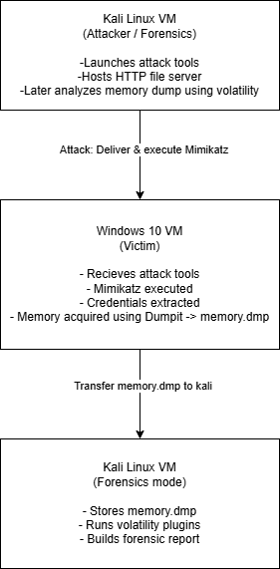

**Explanation**

This diagram summarizes the lab structure:  
**Kali Linux (attacker)** ↔ **Windows 10 (victim)**  
▪ Connected only through **Host-Only Adapter**  
▪ No external internet connectivity  
▪ Both VMs maintain **snapshot checkpoints** for repeatability

The architecture ensures the attack is contained without risk to external networks.

## 2. Virtual Machine Configuration

### 2.1. Kali Linux Configuration

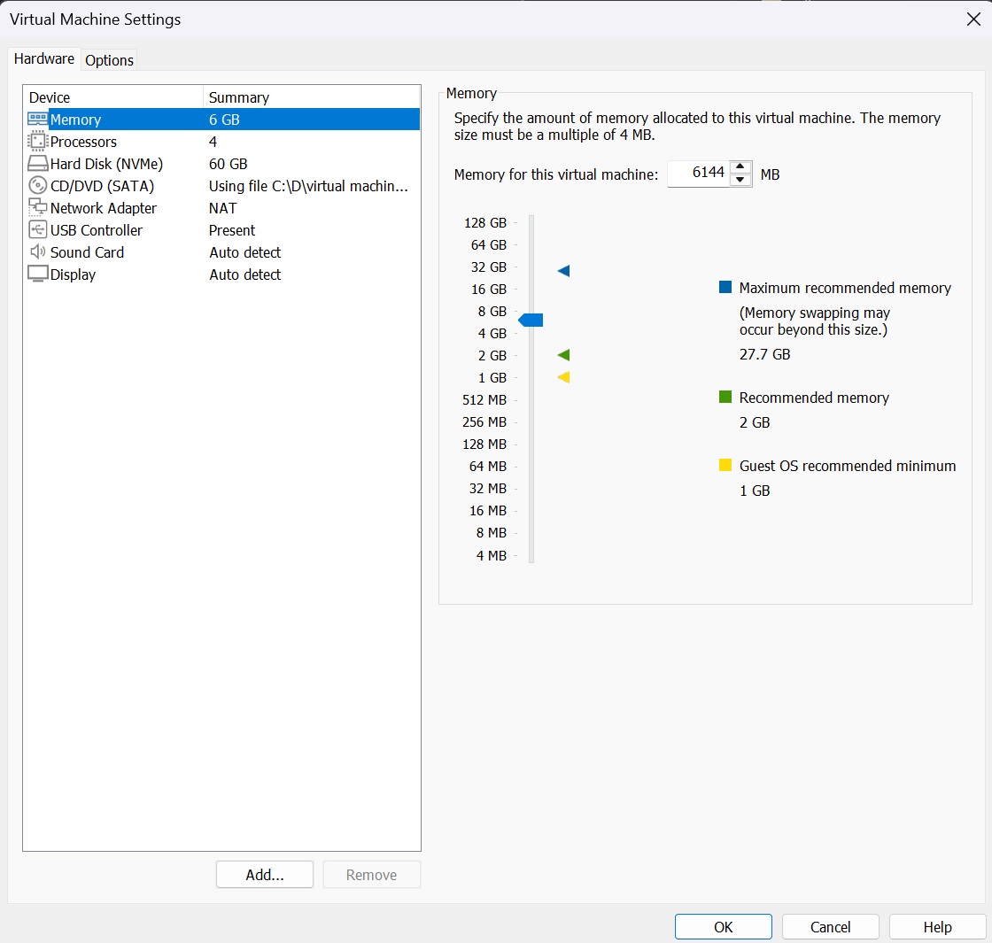

**Explanation**

This screenshot documents the Kali Linux VM configuration:

* Network mode set to **Host-Only Adapter**
* Adequate CPU & RAM allocation
* Virtual hardware configured for tool compilation, HTTP service hosting, and running forensic toolchains.

This acts as the attacker platform for **Mimikatz deployment**, **DumpIt execution**, and **Volatility analysis**.

### 2.2. Windows 10 Configuration (Victim Machine)

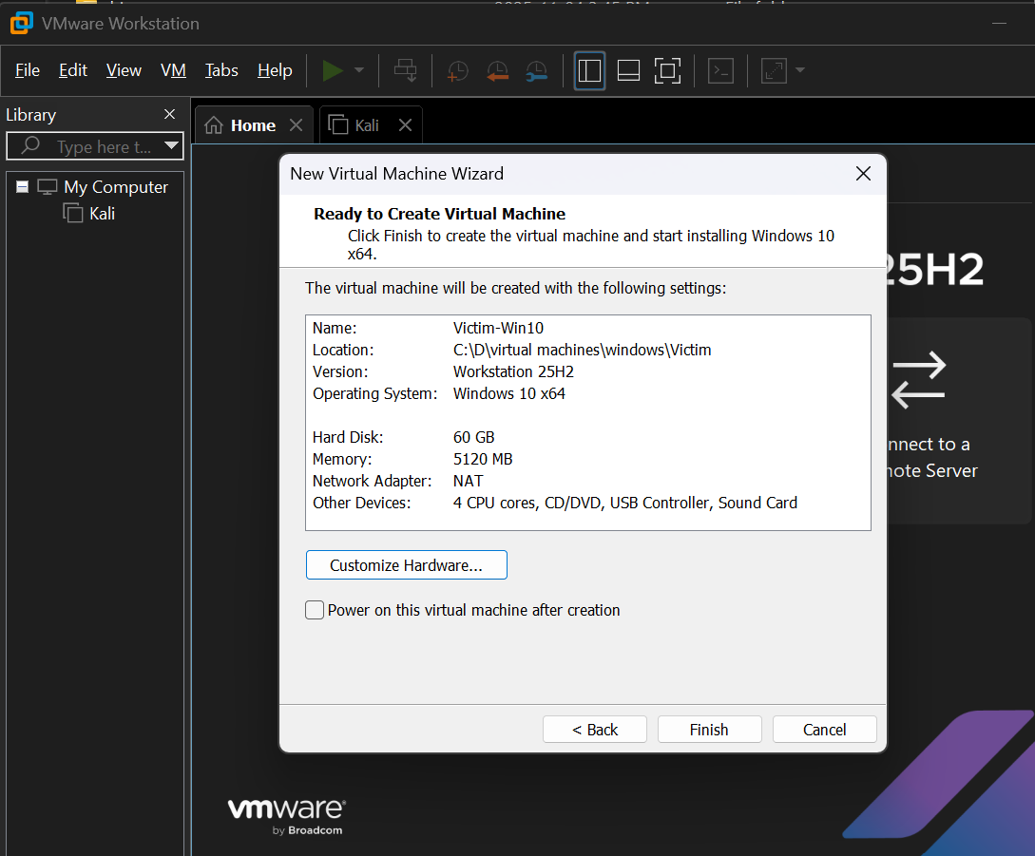

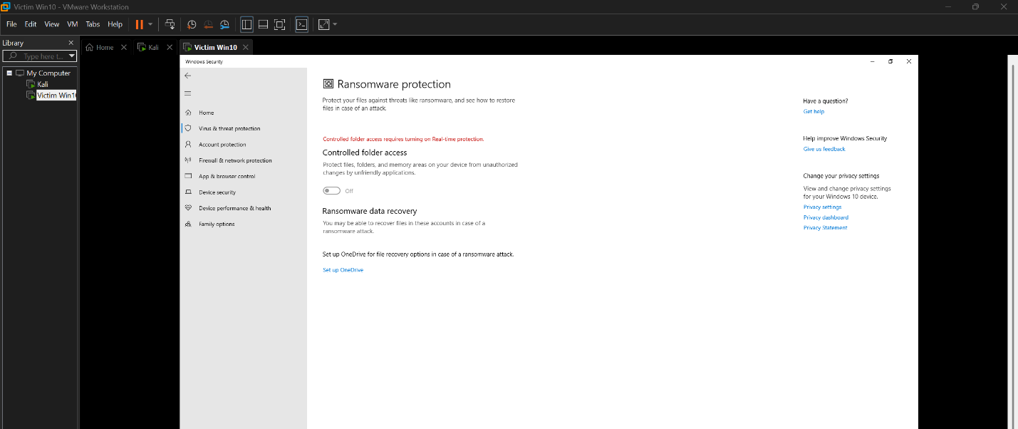

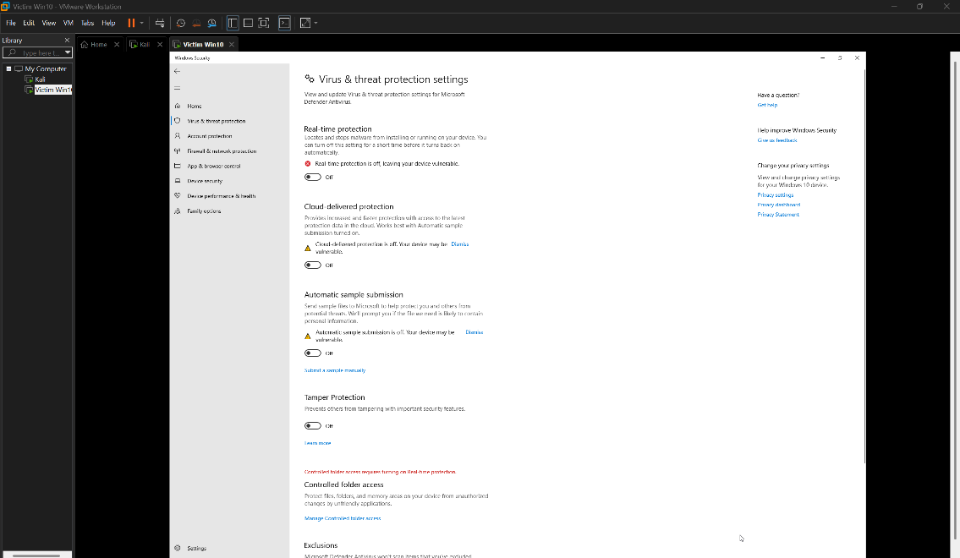

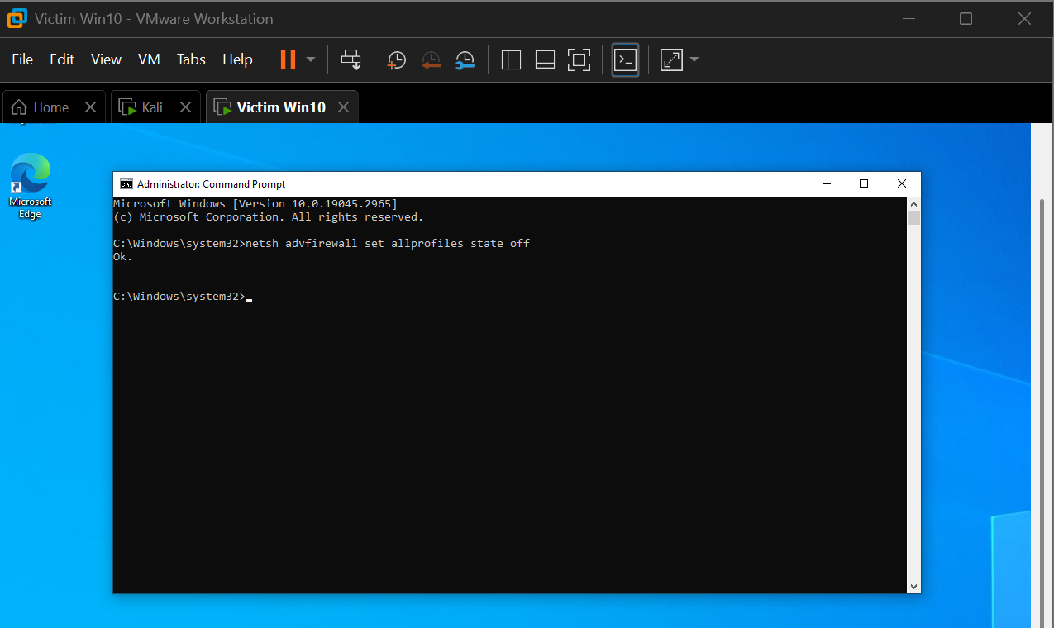

**Explanation**

The Windows 10 victim machine is configured to simulate a realistic vulnerable endpoint:

* **Controlled Folder Access disabled**  
  → Allows the attacker to place tools (DumpIt, Mimikatz) without Microsoft Defender interference.
* **Security protections and real-time scanning disabled**  
  → Ensures the attack tools execute without obstruction.
* **Windows Firewall turned off**  
  → Required for enabling inbound/outbound communication during attack staging.

These configurations are necessary to enable **credential dumping**, memory acquisition, and remote interaction.

## 3. Creation of Required Directories & Tool Placement

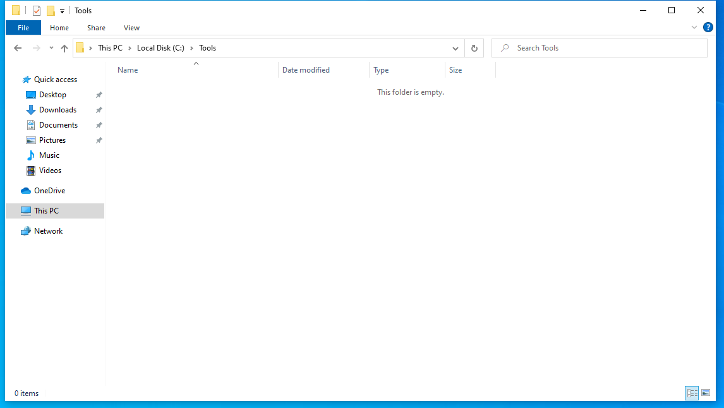

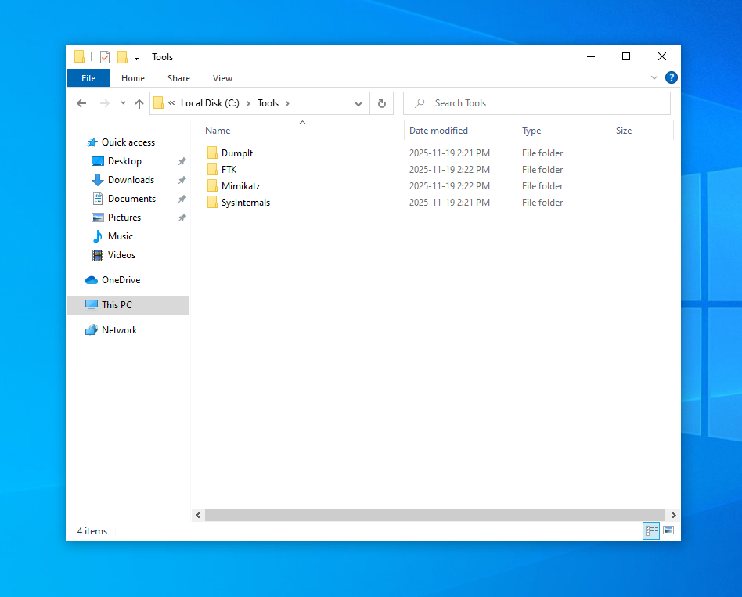

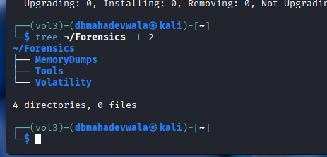

**Explanation**

Dedicated folder structures were created to maintain clean segregation between:

* **Attack Tools** (DumpIt.exe, mimikatz.exe)
* **Forensics Tools**
* **Generated Memory Dumps**

This organization is crucial for:

* Repeatability of experiments
* Clean pre-attack baseline captures
* Minimizing contamination of analysis artifacts

## 4. Snapshot Creation for Reproducibility

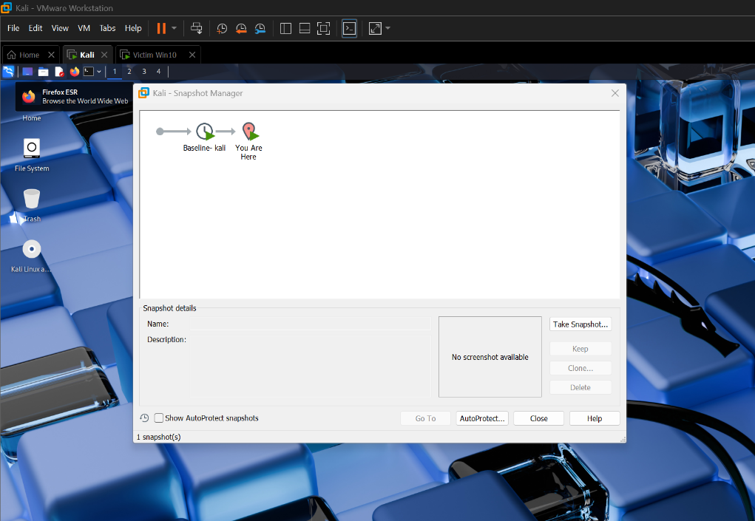

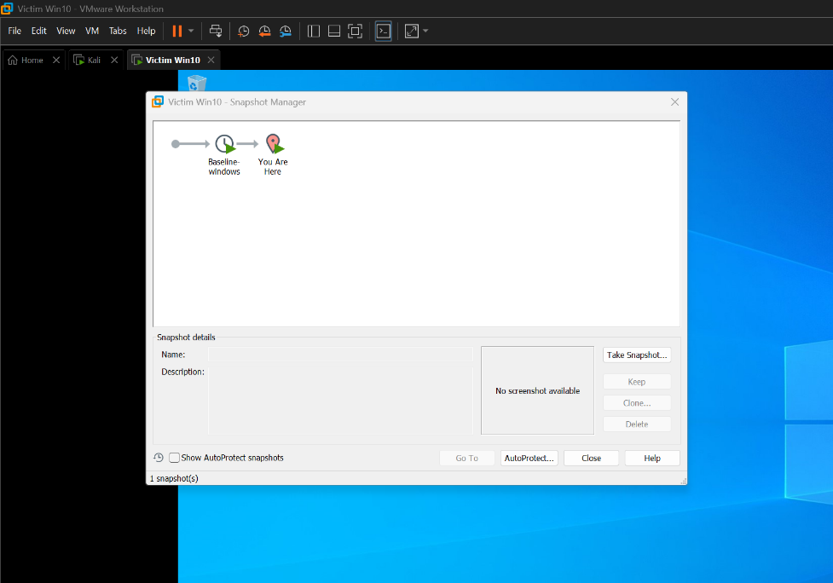

**Explanation**

Snapshots were captured after configuring both VMs but before deploying any attack tools.  
This ensures:

* The **baseline state is preserved**
* Memory dumps represent clean and attack states accurately
* Any configuration mistakes can be reverted instantly

Snapshots form the foundation of **Phase 3 comparative analysis**.

## 5. Installation & Validation of Required Tools

### 5.1. Mimikatz Restrictions (Verification)

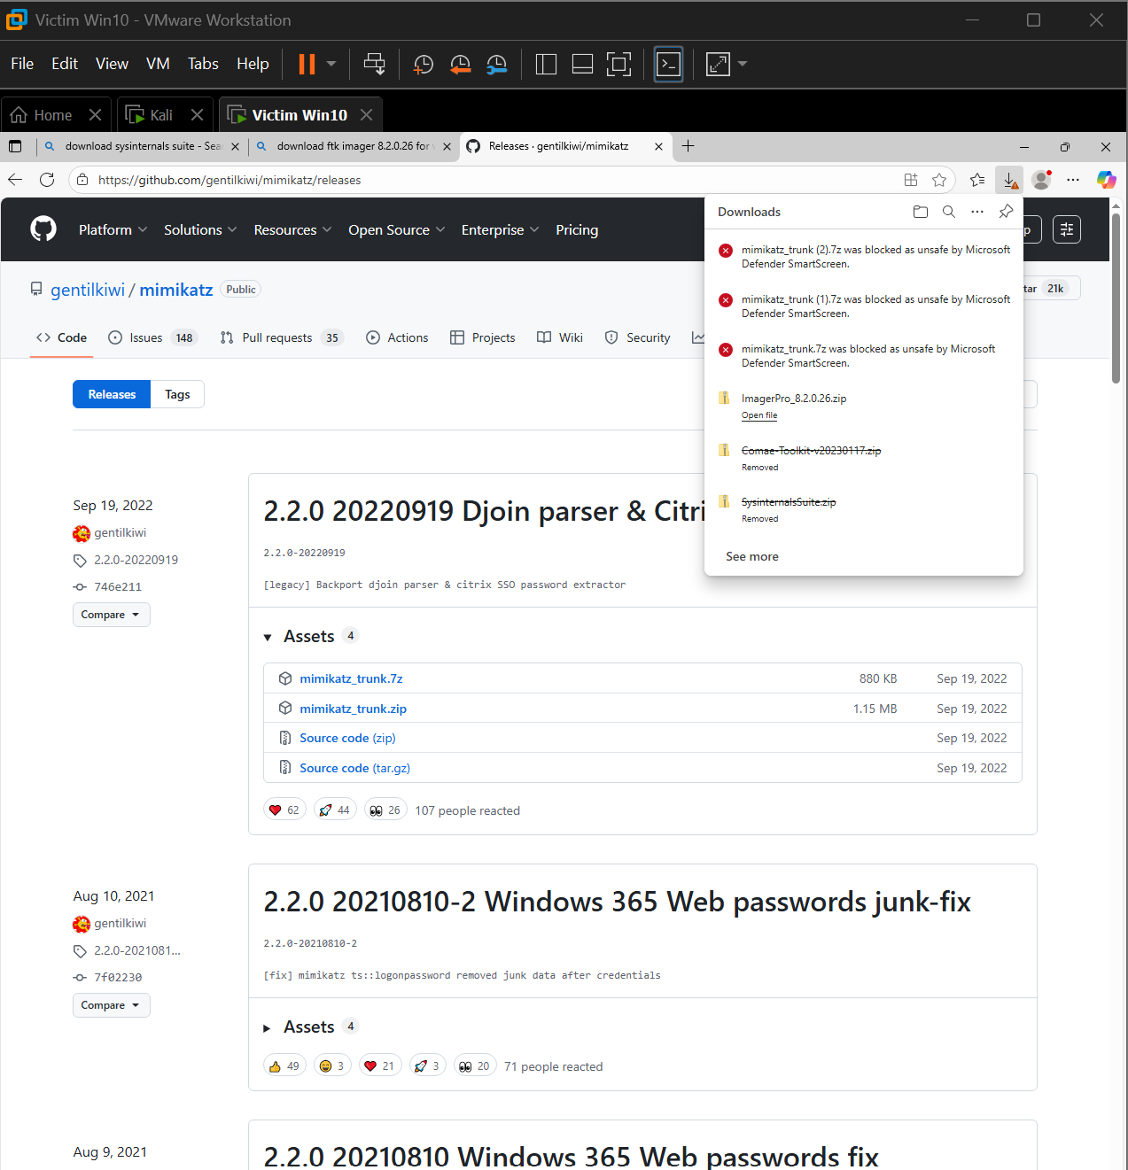

Windows Defender blocks Mimikatz downloads under normal conditions.  
This screenshot demonstrates why **security controls had to be temporarily disabled**.  
This is not an attack action—only documentation of baseline Defender behavior.

### 5.2. Installing Volatility 3 (Kali)

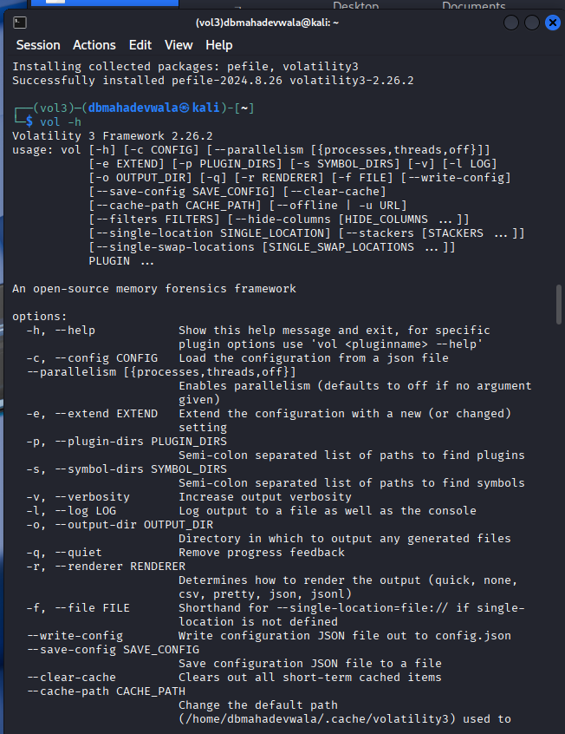

Volatility 3 is installed in Kali as the primary tool for:

* Memory parsing
* Process reconstruction
* Handle and module enumeration
* Credential extraction analysis (PSList, DLLList, Handles, Netstat)

This prepares the forensic side of the lab.

### 5.3. Updating Tooling & Dependencies in Kali

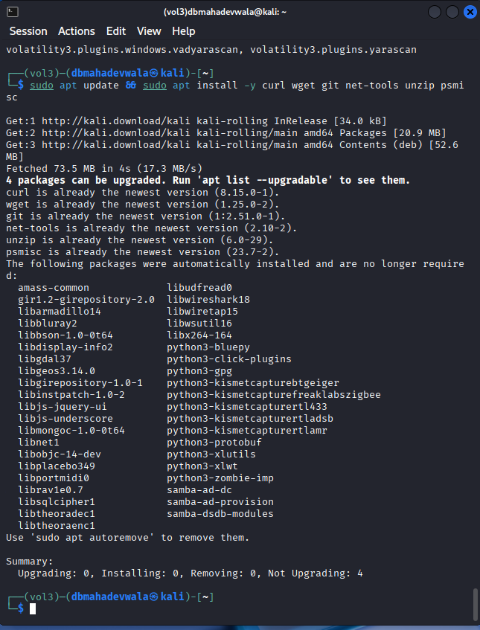

This ensures Python, networking libraries, Volatility dependencies, and HTTP server modules are up-to-date.

## 6. Network Configuration & Connectivity Tests

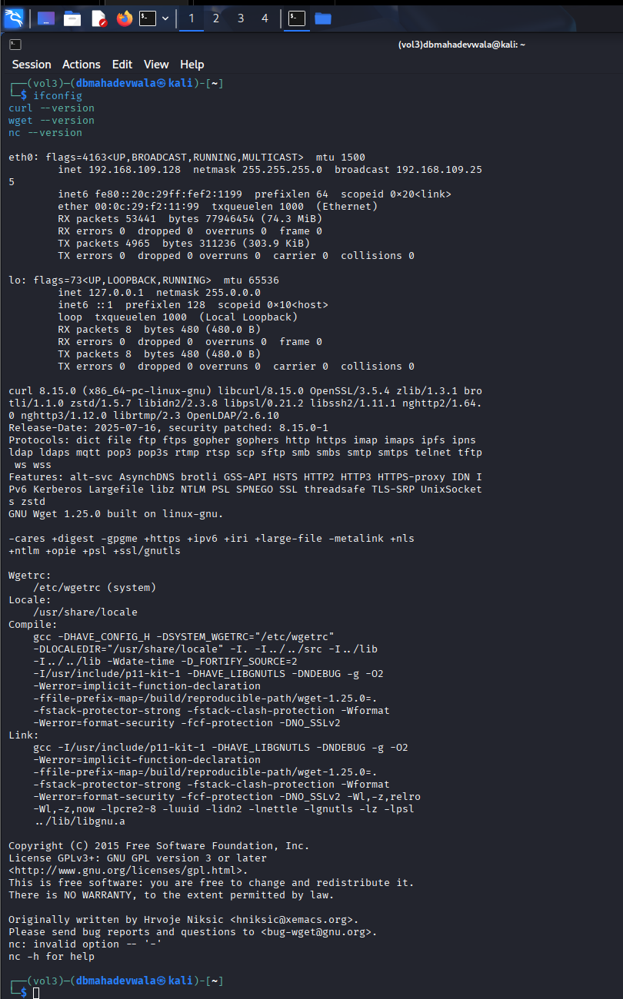

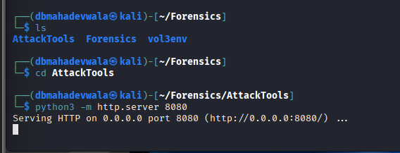

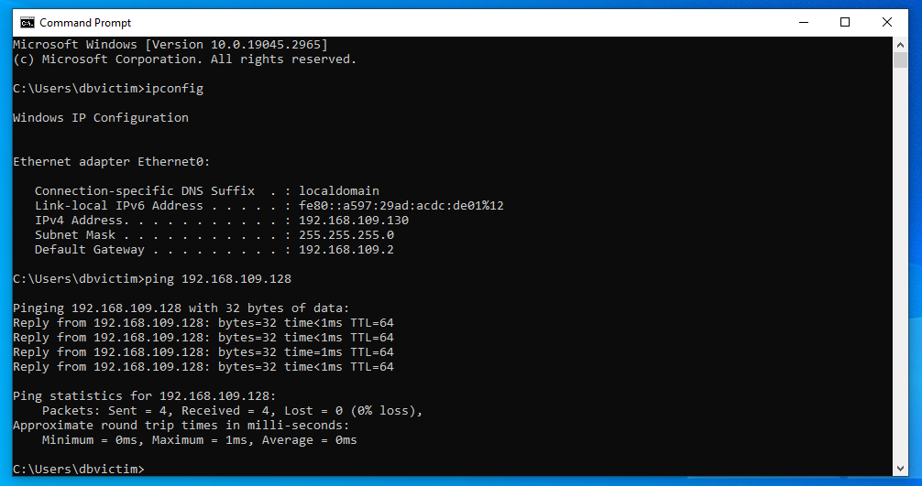

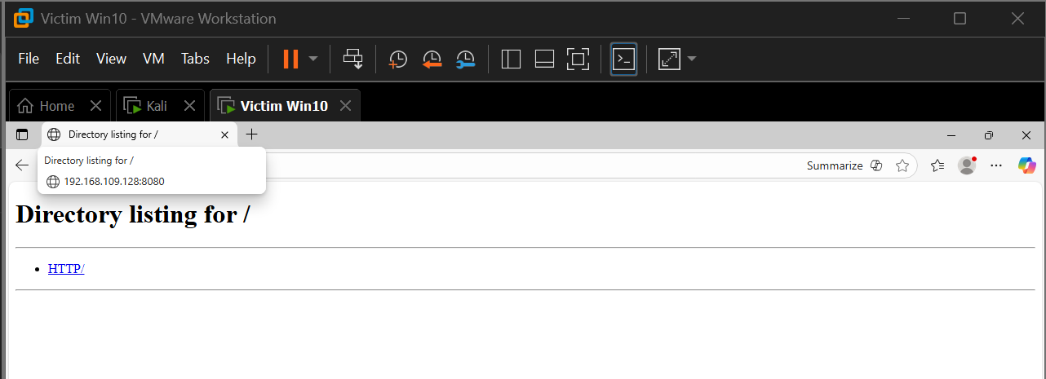

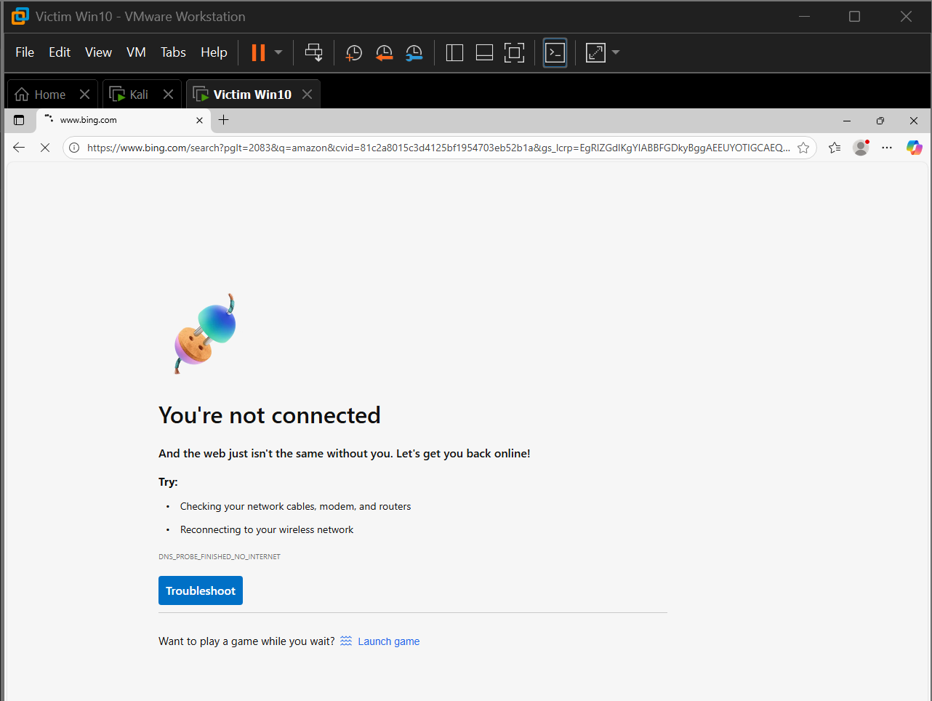

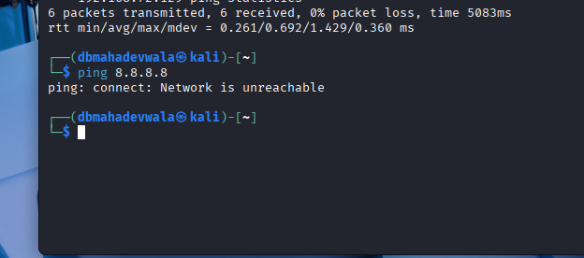

**Explanation**

This section validates controlled connectivity between attacker and victim:

**What we verified:**

✔ Both machines communicate bidirectionally via **Host-Only network**  
✔ No external internet access (confirmed via browser tests and failed DNS pings)  
✔ HTTP server on Kali serves content accessible from Windows  
✔ ICMP reachability confirmed both ways

**Why this matters:**

* Ensures **attack traffic stays inside the lab**
* Allows file transfer from attacker to victim
* Guarantees realistic but safe offensive testing

## 7. Final Phase 1 Validation Summary

At the end of Phase 1, we confirmed that:

* Both VMs are properly configured
* Tools are installed and structured
* Security controls are disabled intentionally
* Network environment is isolated
* Snapshots are in place
* Connectivity is established
* Internet is isolated from both machines
* Directory structure is prepared for upcoming phases

**This completes Phase 1 and provides a stable foundation for Phase 2 (attack execution and memory dumps).**

# Phase 2 – Attack Delivery, Execution, and Memory Acquisition

This phase documents the preparation, execution, and capture of malicious activity within the controlled laboratory environment. The attacker (Kali Linux) delivered a sequence of payloads to the victim (Windows 10), executed credential-theft tools, and captured memory artifacts before and after the attack. This section outlines the methodology, tools used, and supporting screenshots that demonstrate each procedural step.

## 2.1 Preparation of the Attacker Environment

### 2.1.1 Verifying Attacker Network Connectivity

The attacker machine’s IP configuration was confirmed to ensure stable communication with the Windows victim over the host-only interface.

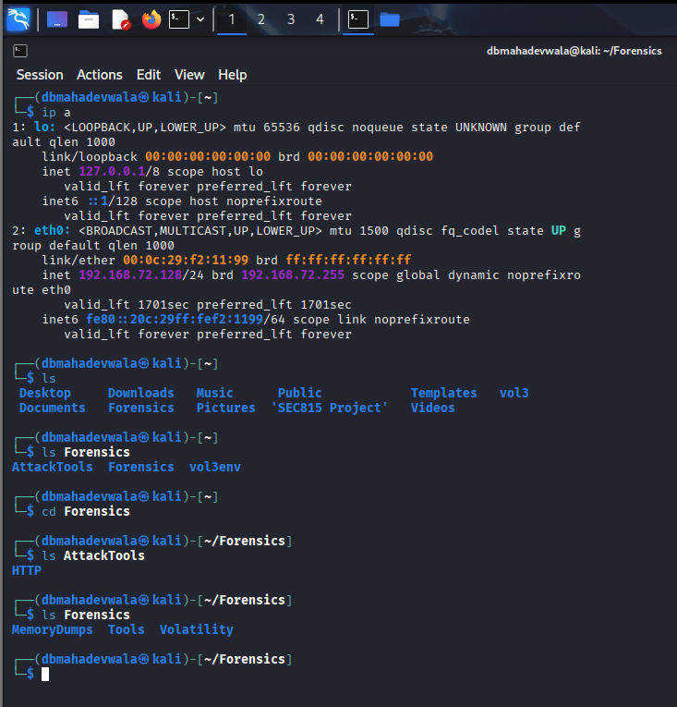

This screenshot confirms the attacker’s assigned IP address (192.168.72.128) and verifies the file system location from which the attack tools will operate.

### 2.1.2 Creating a Payload Staging Area

A dedicated folder was configured on Kali to host the attack tools and payloads used during exploitation.

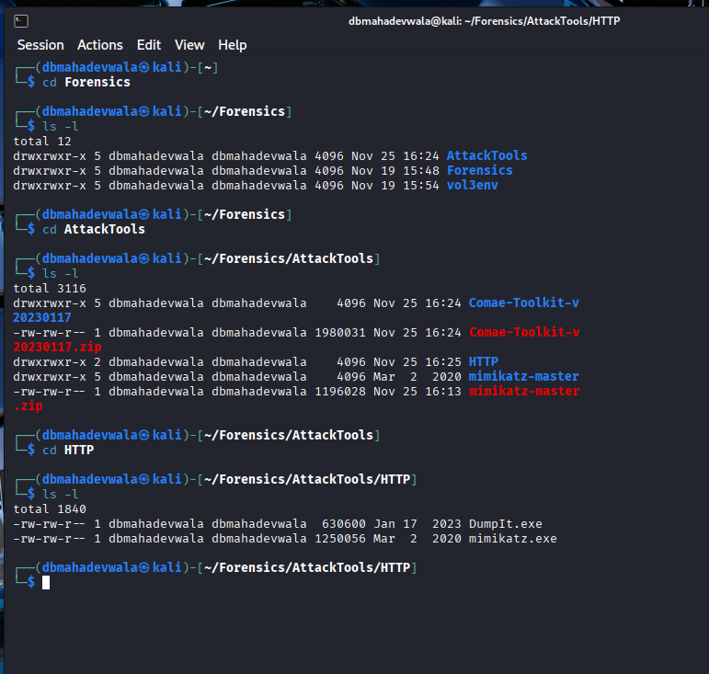

This directory contains the malicious binaries, including DumpIt.exe and Mimikatz, ensuring clean separation between system files and attack materials.

### 2.1.3 Hosting an HTTP Server for Payload Delivery

To transfer malicious binaries to the Windows system, a lightweight Python HTTP server was launched from within the attack directory.

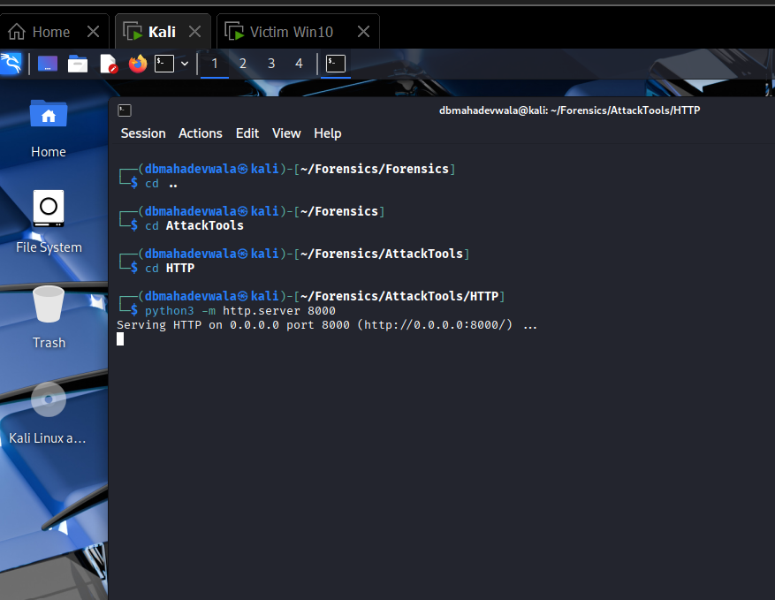

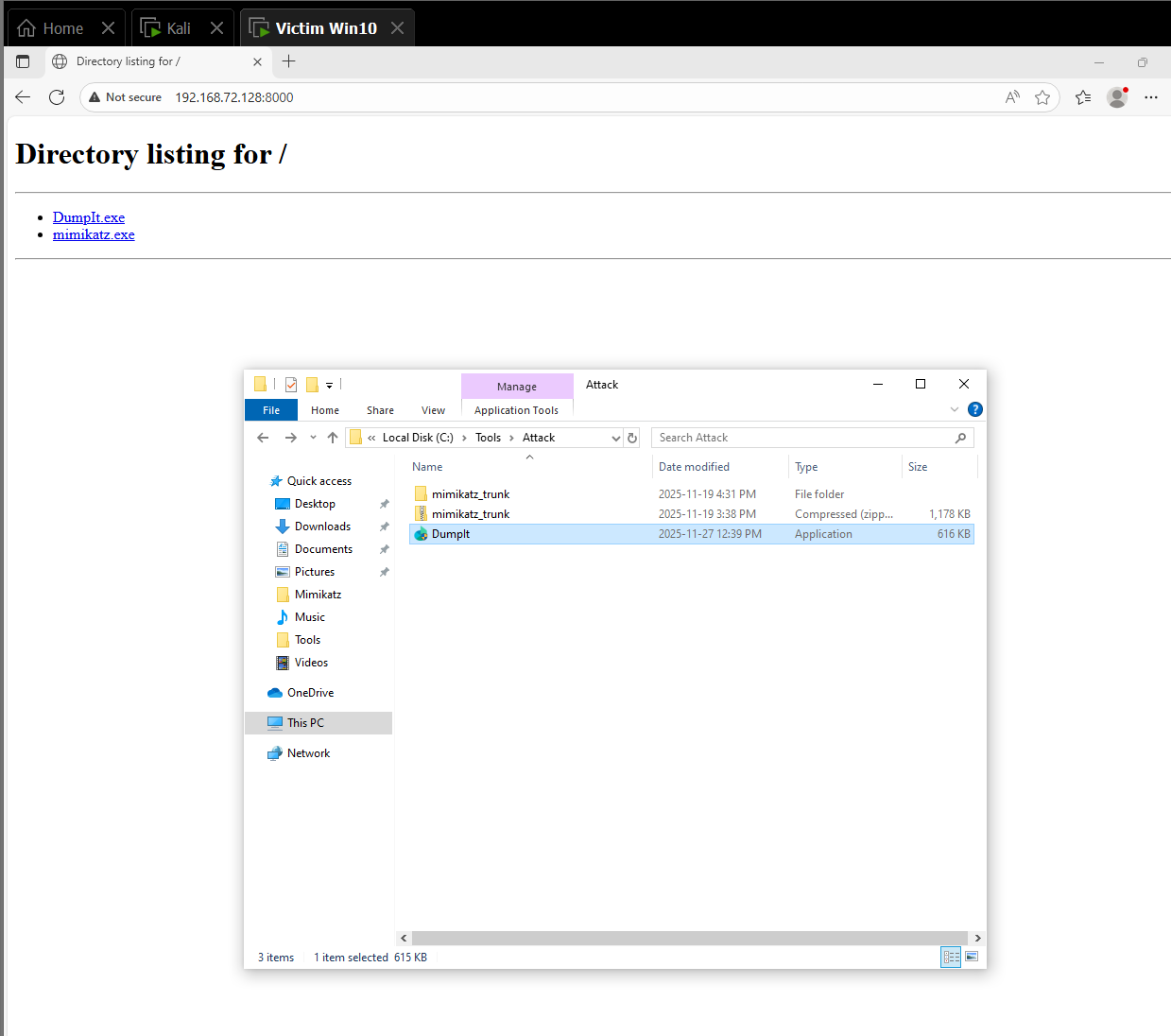

These screenshots illustrate how the attacker initiated the HTTP service and how the victim subsequently accessed it using a web browser to retrieve the DumpIt executable.

## 2.2 Preparation of the Victim Environment

### 2.2.1 Disabling Security Controls

To ensure the malicious payloads executed without interference, Windows Defender and firewall policies were manually disabled.

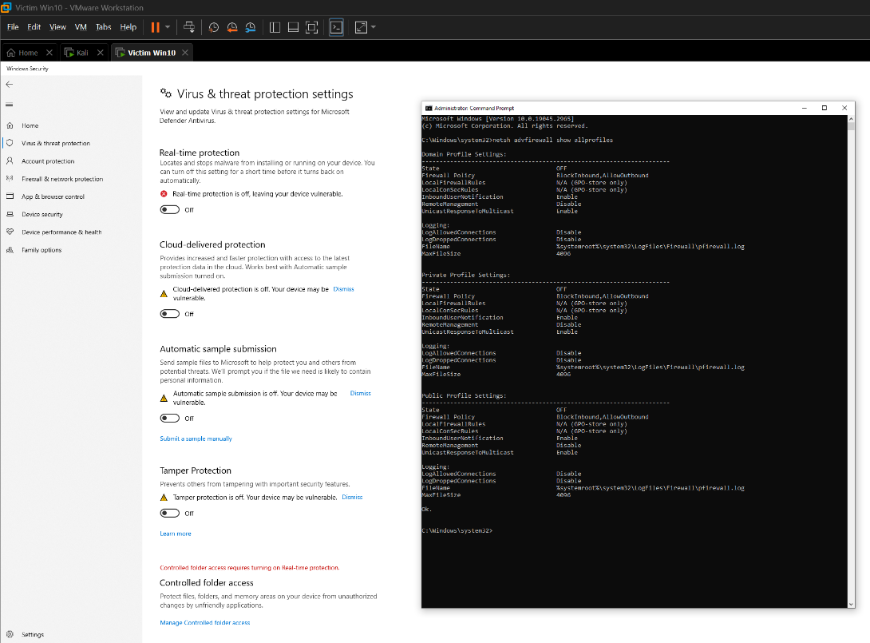

These configurations ensured the attacker-delivered binaries (DumpIt.exe, Mimikatz.exe) would run unimpeded.

### 2.2.2 Verifying Remote Accessibility

RDP access and folder permissions were confirmed to support attack phases including tool execution and file retrieval.

### 2.2.3 Preparing Tool Directories

Dedicated folders were created within the Windows host to store the incoming malicious tools.

## 2.3 Pre-Attack Memory Capture

Prior to executing any malicious tools, a baseline memory snapshot was collected. This allows later comparison against the compromised memory state.

### 2.3.1 Running DumpIt.exe Before the Attack

DumpIt was executed from the victim’s Windows host to generate the pre-attack memory image.

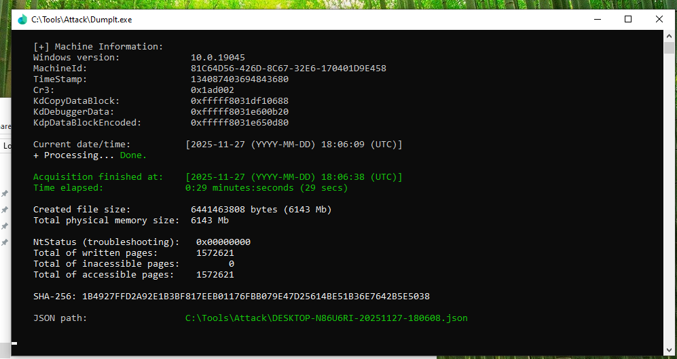The resulting memory dump was transferred back to the Kali system for analysis in later phases.

## 2.4 Downloading and Executing Attack Tools

### 2.4.1 Downloading Mimikatz from the Attacker Server

Mimikatz was retrieved onto the victim system directly through the attacker-controlled HTTP server.

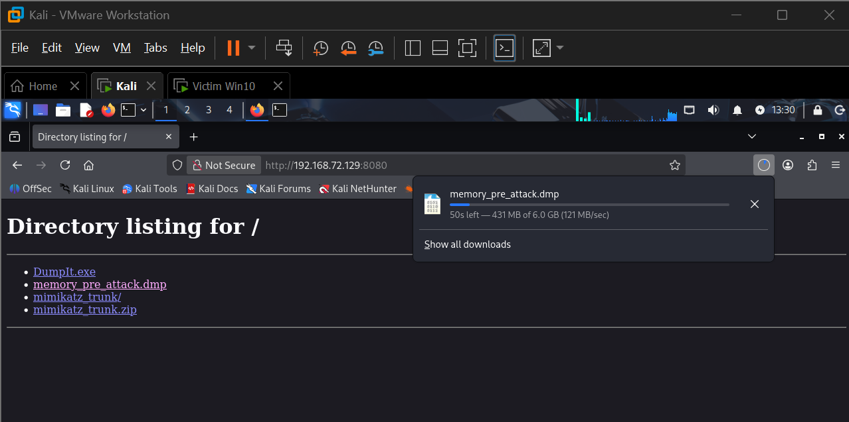

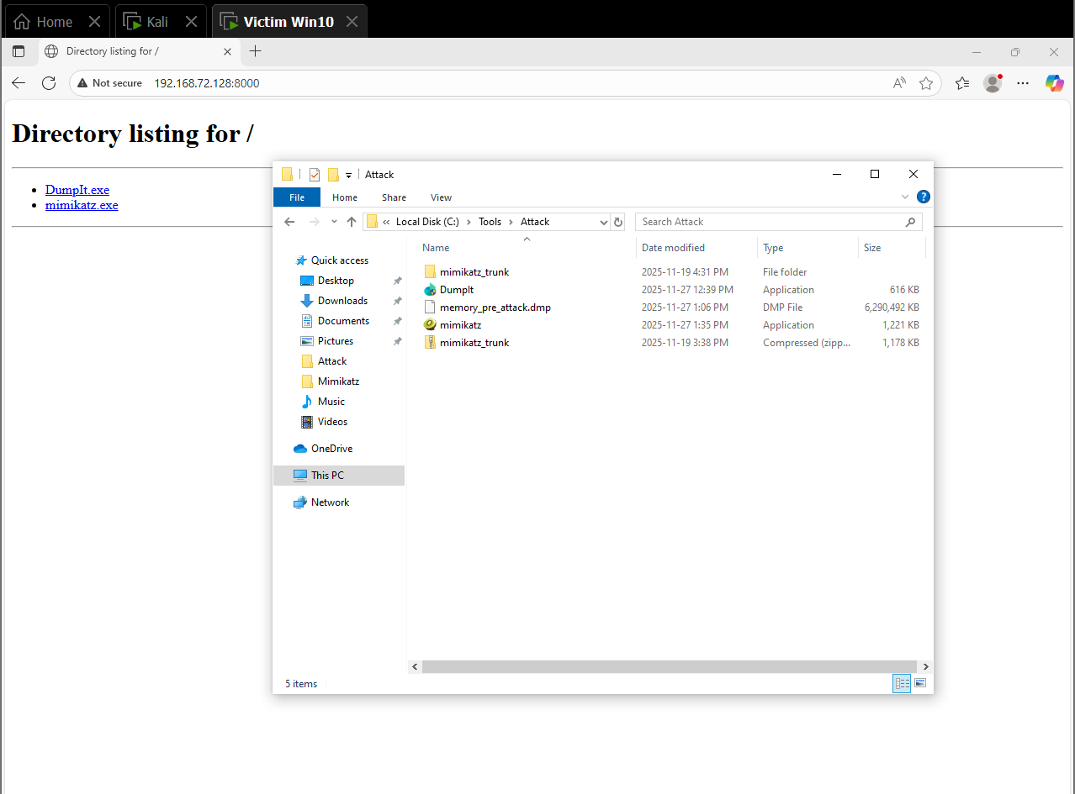

This confirms successful payload delivery from the attacker to the victim.

**2.4.2 Executing Mimikatz on the Victim**

Mimikatz was executed on the Windows host to extract sensitive credential material.

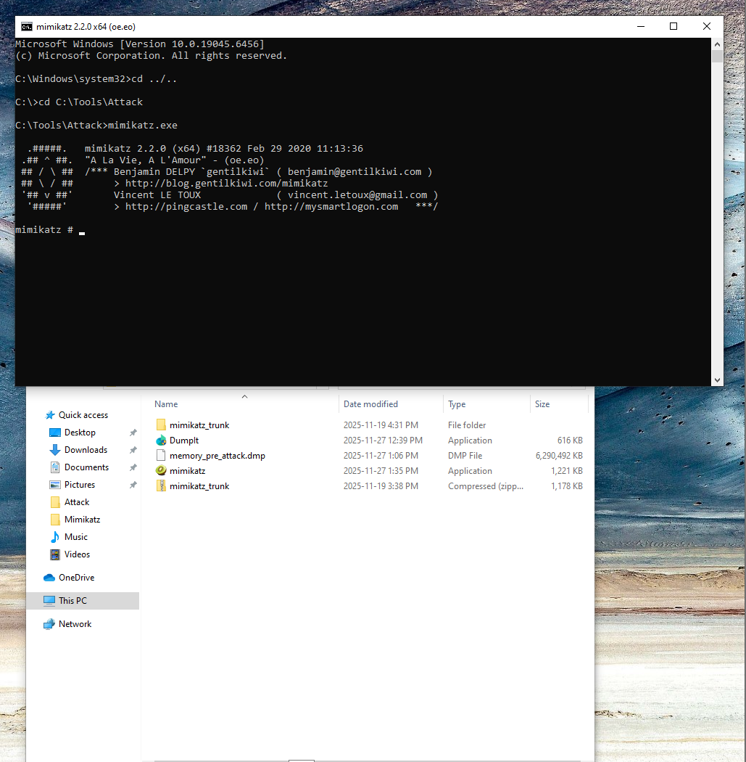

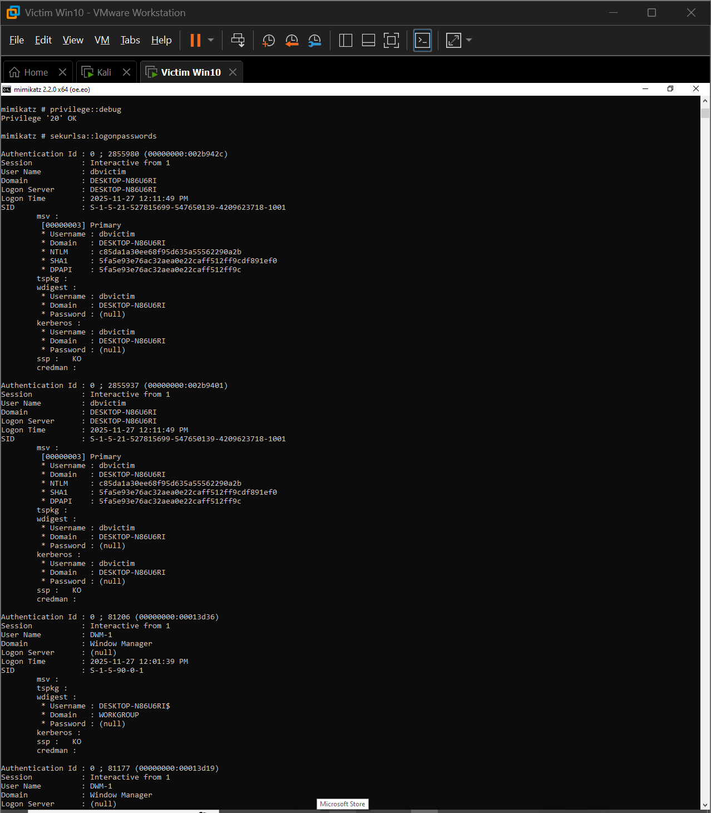

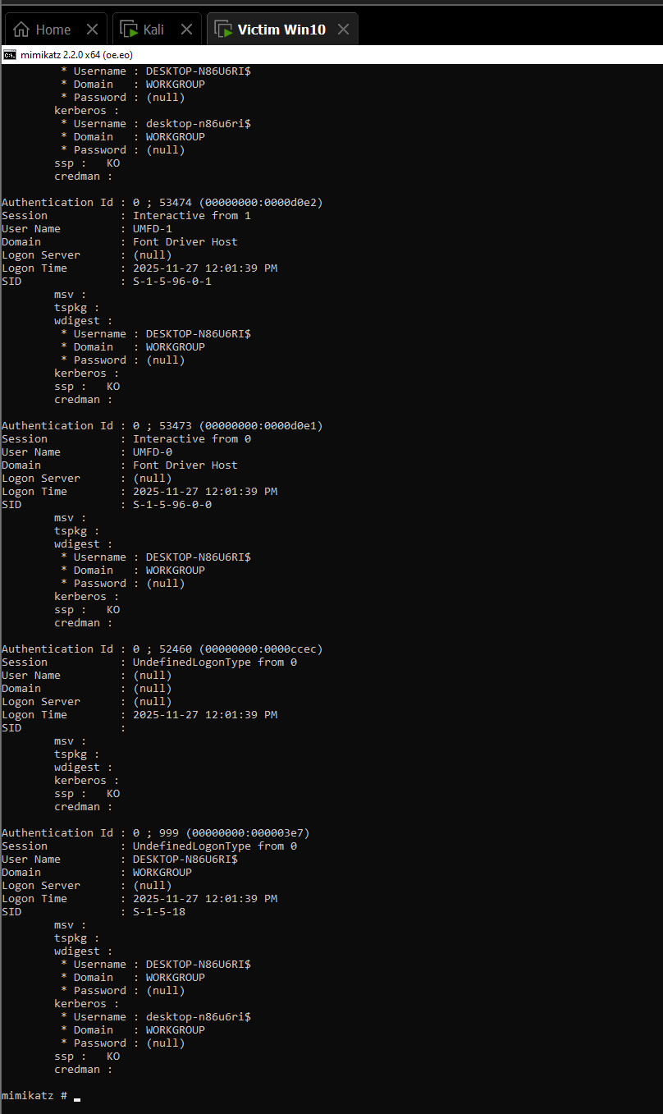

These illustrate the execution of sekurlsa::logonpasswords and other credential-theft modules.

## 2.5 Memory Capture During the Attack

With Mimikatz running, a second memory dump was captured. This ensures the malicious activity—including active credential harvesting—is preserved for forensic analysis.

### 2.5.1 DumpIt Executed During Live Mimikatz Session

DumpIt was executed again to produce the “attack-state” memory image.

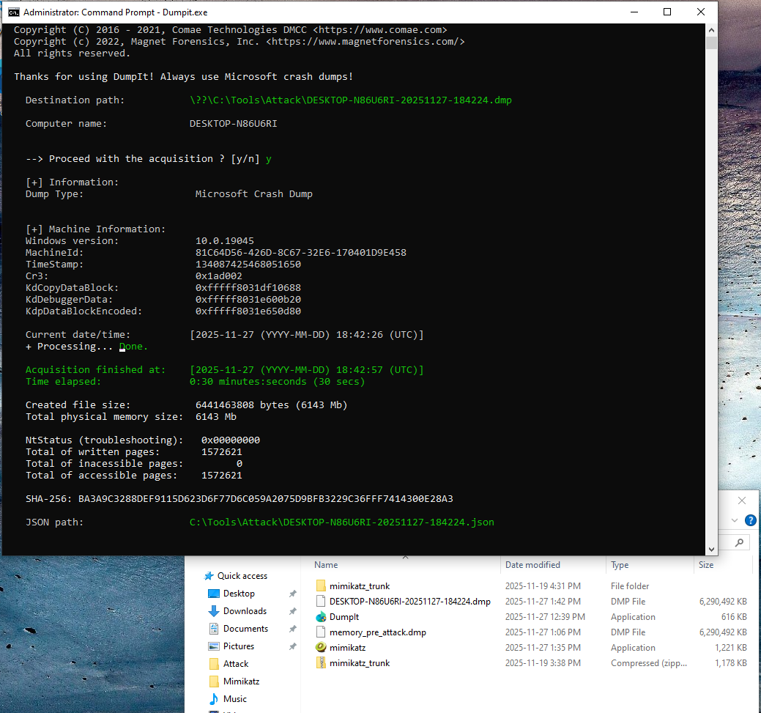

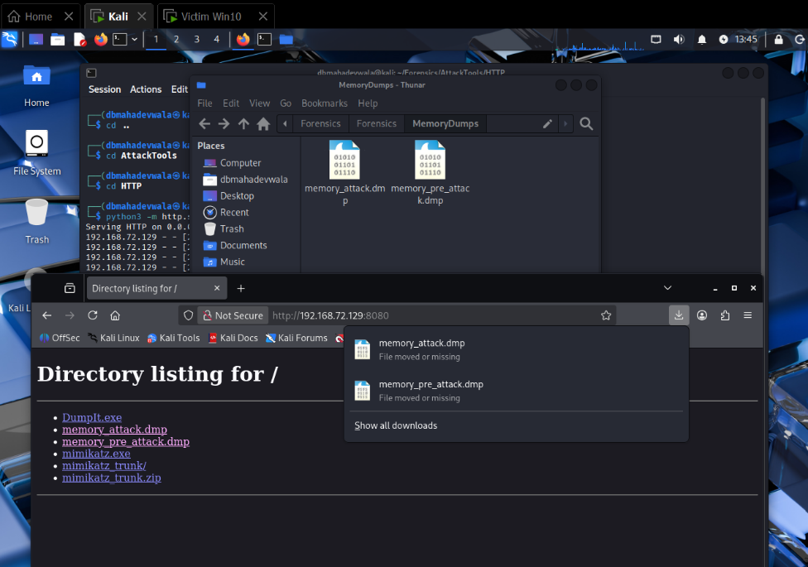

Both attacker and victim views confirm successful capture and transfer of the dump to the analysis environment.

### 2.5.2 Termination of Mimikatz

After memory acquisition, the Mimikatz process was terminated.

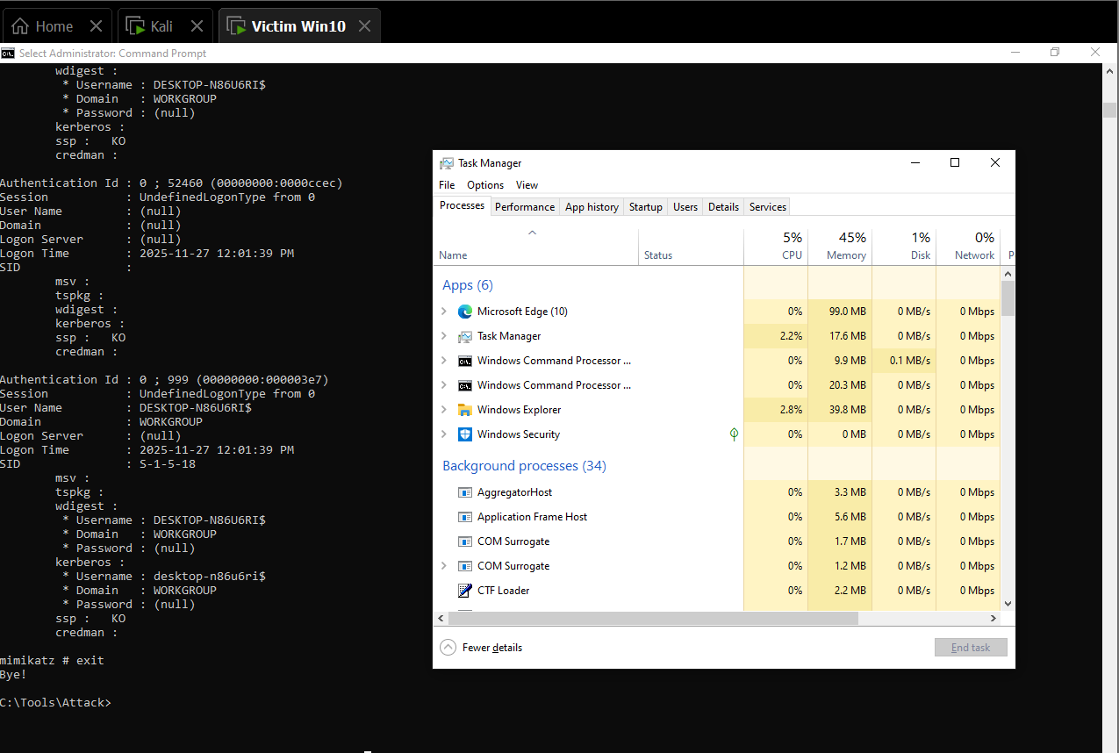

This marks the end of active compromise activity.

## 2.6 Post-Attack Memory Acquisition

To create a third comparison point, a final memory dump was taken after all malicious activity ceased.

### 2.6.1 Capturing the Post-Attack Dump

DumpIt was executed once more, collecting the memory state after the attack had been cleaned up.

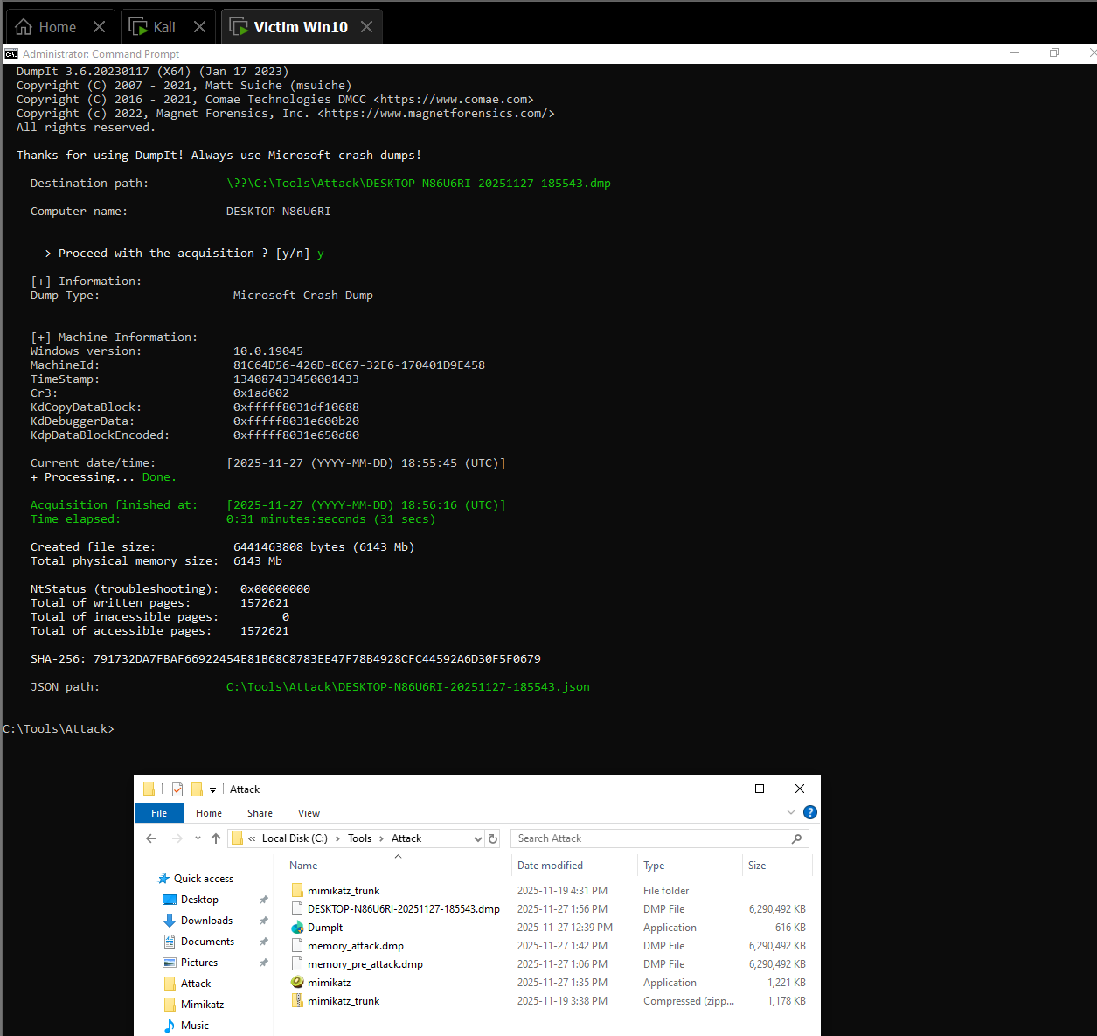

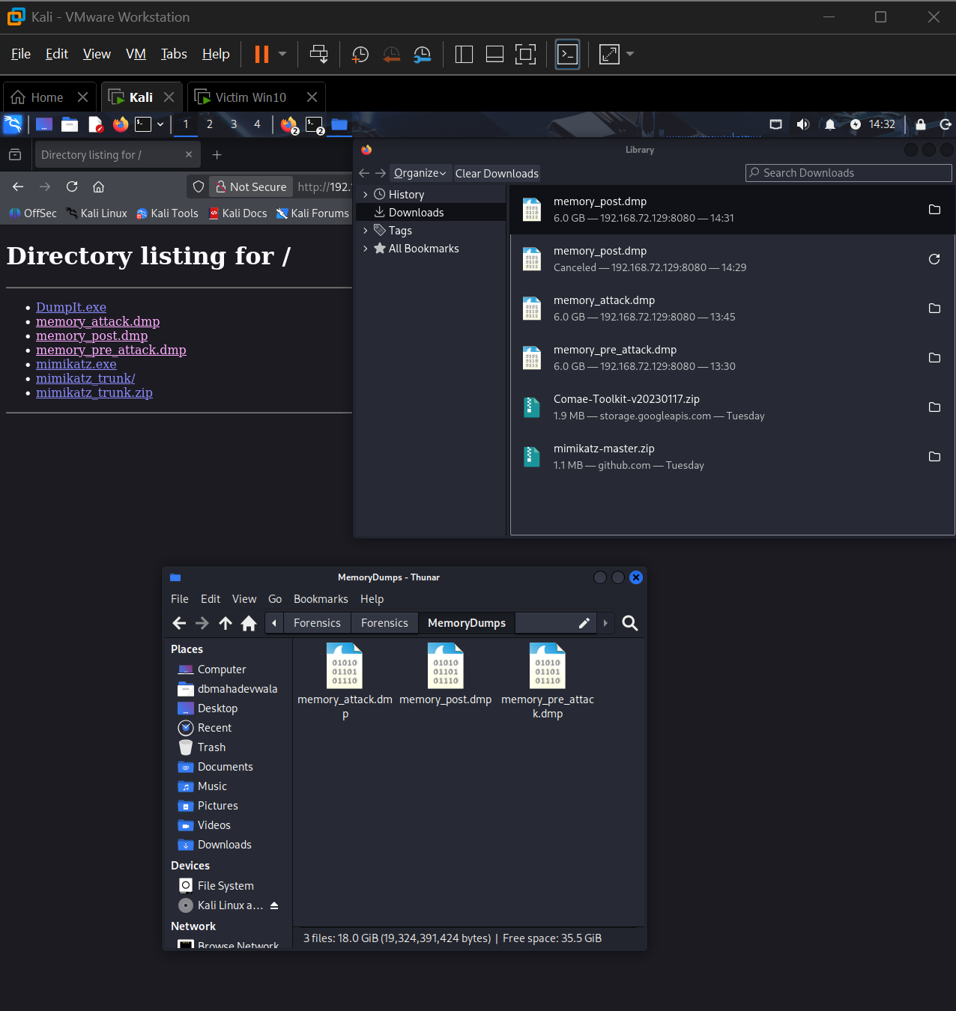

This dump allows examiners to differentiate between persistent artifacts and transient attack elements.

# Phase 3 – Memory Forensics with Volatility 3 (Pre-, During- and Post-Attack)

This phase documents how the three memory images were analysed with Volatility 3 and how the results were used to reconstruct the attack and its impact. The analysis follows the incident-response timeline: baseline (pre-attack), live attack, and post-attack state, then compares them side-by-side.

## 3.1 Tool preparation and image integrity

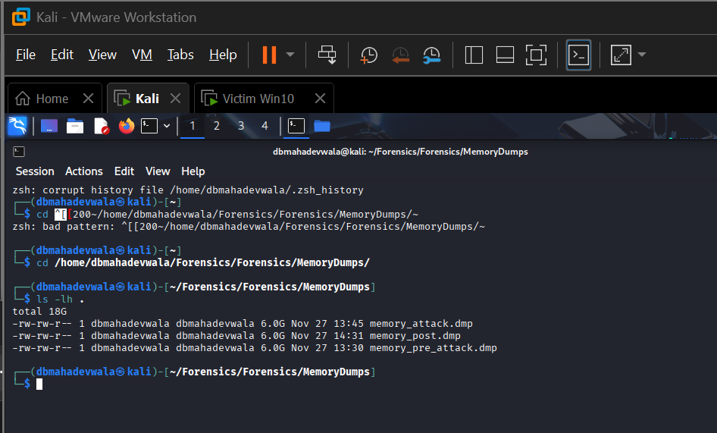  
This screenshot lists the three memory images (memory_pre_attack.dmp, memory_attack.dmp, memory_post.dmp) in the MemoryDumps directory. It establishes that all later analysis is based on separate acquisition points and that the filenames clearly encode the capture time relative to the attack.

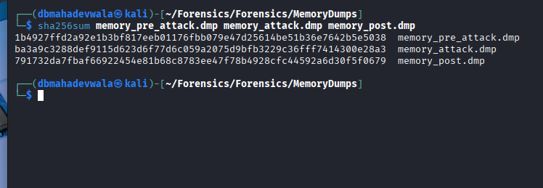

The terminal output shows distinct SHA-256 hashes for each dump. From a DFIR standpoint this proves:

* Each file is a different capture (no accidental copy-paste of the same image), and
* The hashes can be reused later for chain-of-custody and integrity verification in reports or case notes.

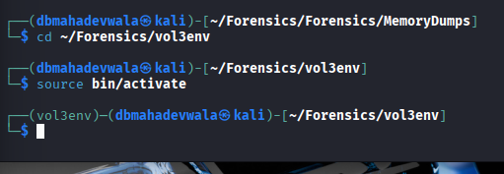

Here the Volatility 3 virtual environment (vol3env) is activated. This demonstrates that:

* Analysis was done in an isolated Python environment,
* Dependencies are pinned and won’t be affected by system-wide package changes, and
* All subsequent vol3 commands were executed with consistent tooling.

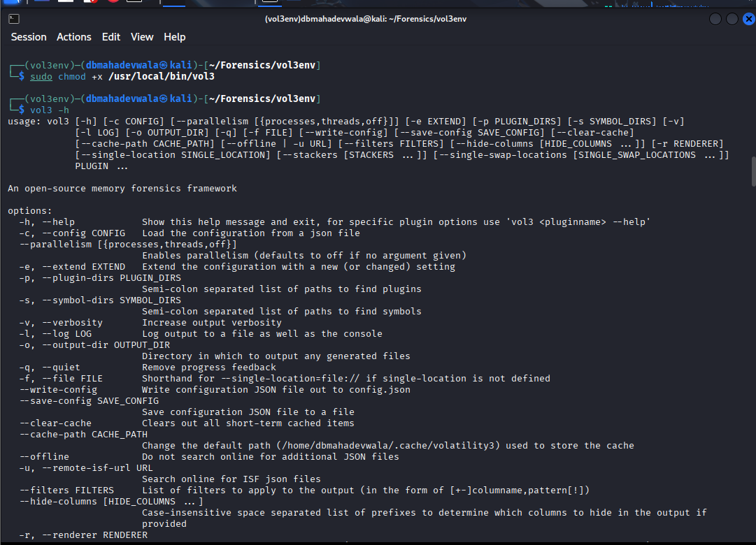

This shows the vol3 -h output. It documents the exact Volatility 3 framework version and available plugins. Including this in the report shows the tool’s capabilities at the time of analysis and supports reproducibility: another analyst can confirm they are using the same version and plugin set.

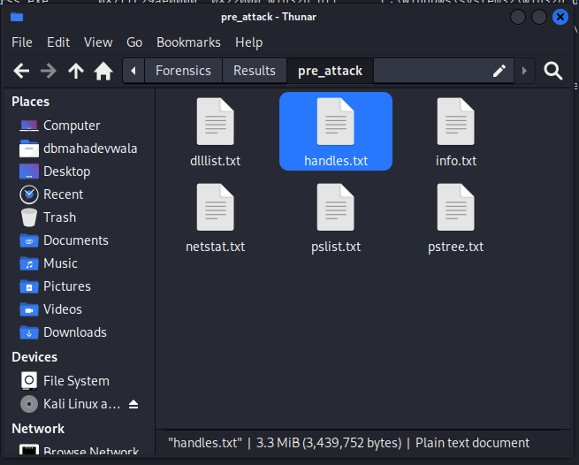

This screenshot captures Volatility downloading symbol files and building the Windows profile the first time the image is analysed. From a forensic perspective this is important because:

* It confirms Volatility successfully identified the OS build and kernel symbols,
* It reduces later ambiguity around plugin reliability, and
* It justifies trusting the subsequent plugin output (pslist, dlllist, handles, etc.) as structurally correct for this Windows build.

## 3.2 Baseline analysis – pre-attack memory image

The pre-attack image represents a clean but fully configured system. This baseline is critical for distinguishing normal activity from malicious artefacts in later dumps.

### 3.2.1 System profile and environment

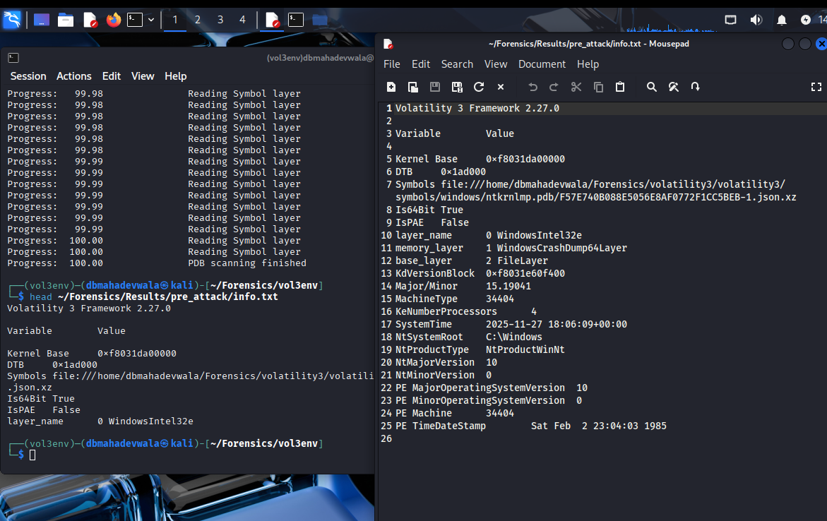

The windows.info.Info / banner output shows details such as:

* Windows version and build number,
* Kernel base address and DTB,
* Processor architecture (64-bit), number of cores,
* System time at the moment of acquisition.

This establishes:

* The victim is a 64-bit Windows 10 host,
* The acquisition timestamp matches the expected “pre-attack” timeline, and
* There is no obvious sign of tampering with basic OS metadata (e.g., wrong time zone or impossible boot time).

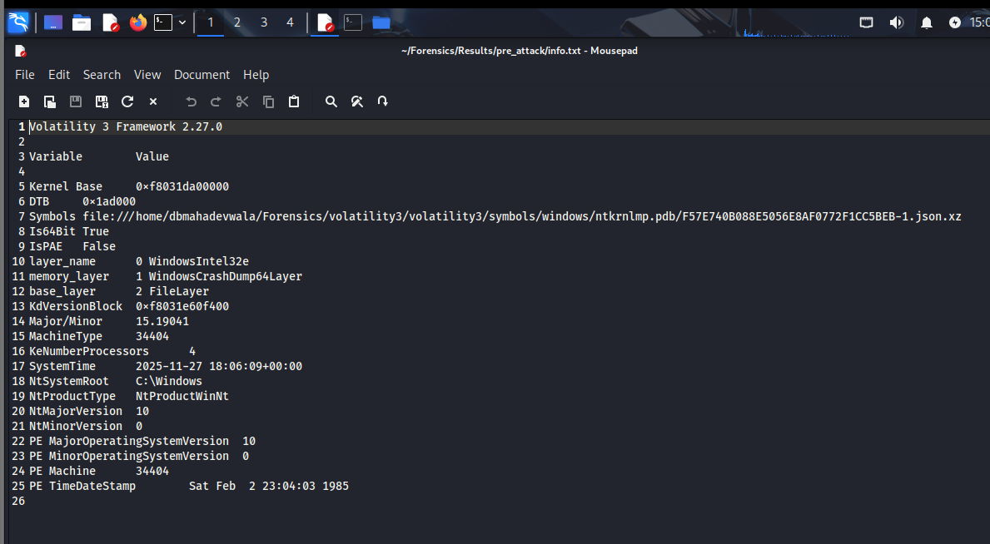

This is the same information exported to a text file under Results/pre_attack/info.txt. Documenting that the output was saved shows proper forensic workflow: analysis is not just done interactively but preserved for later review, peer validation or scripting.

### 3.2.2 Baseline processes

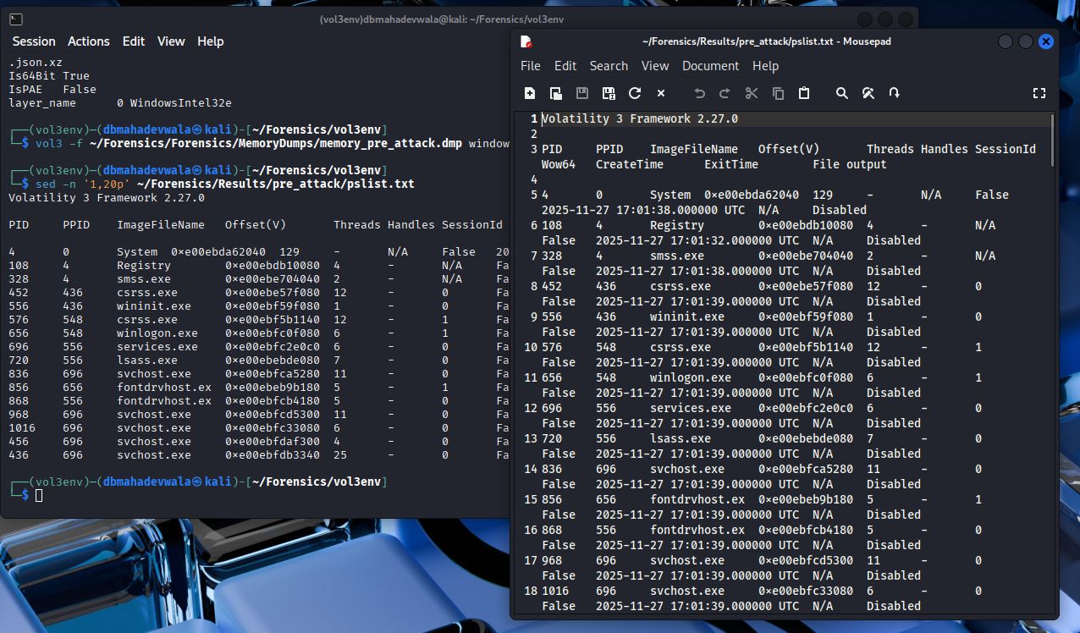

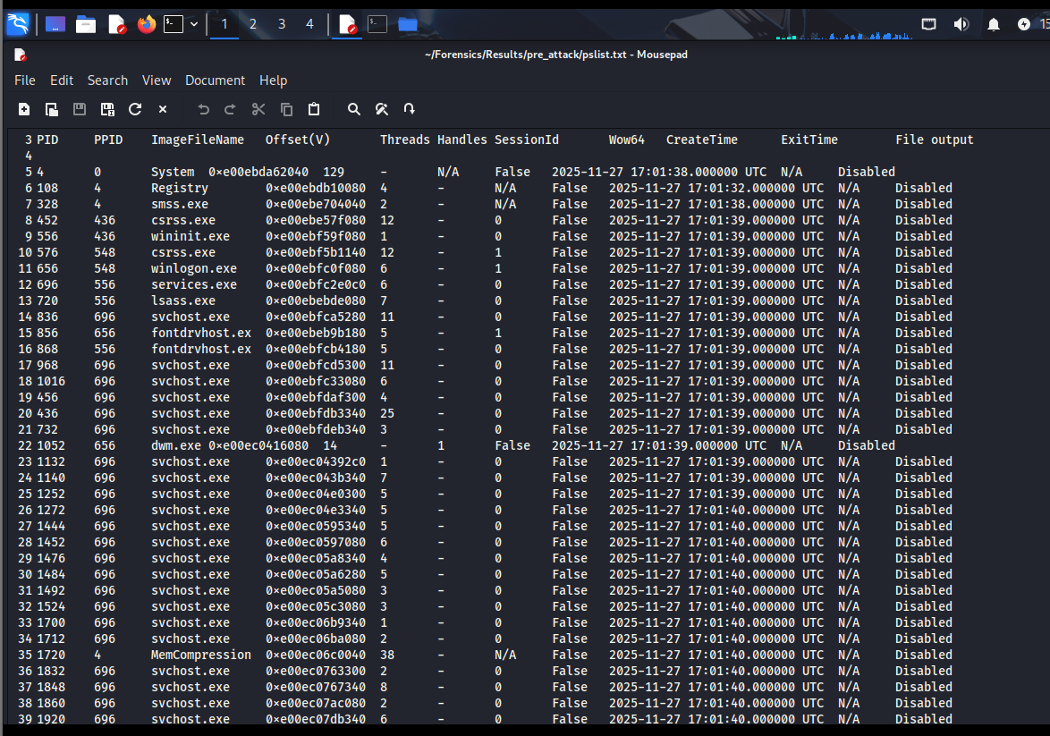

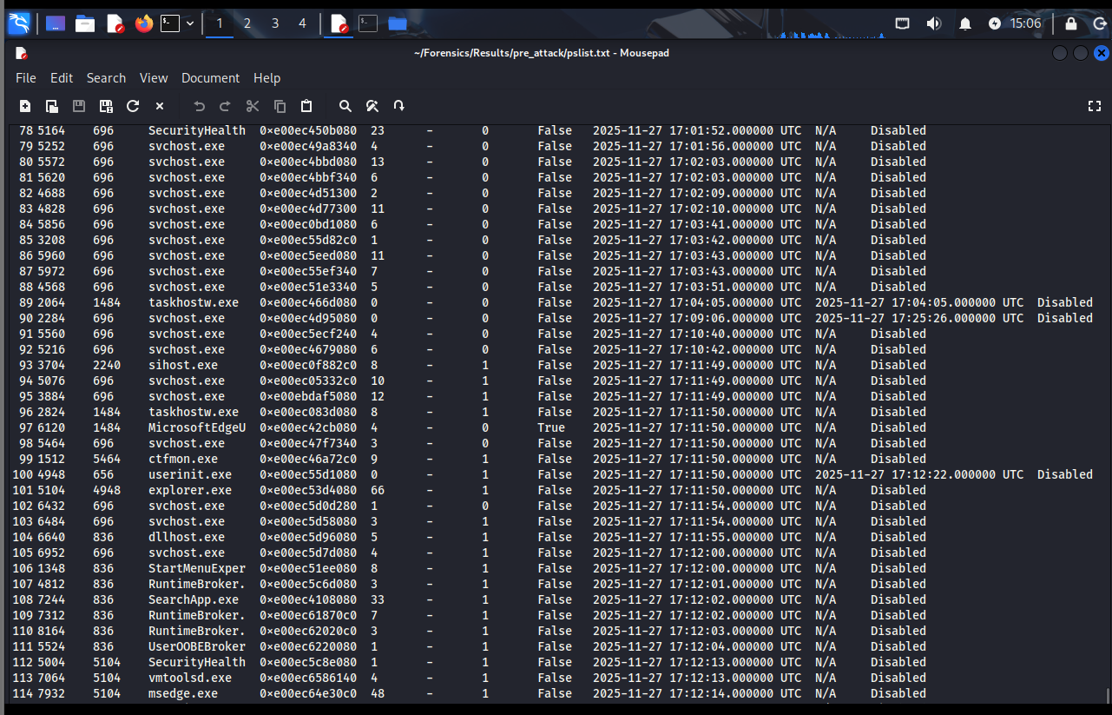

These screenshots show the process list produced by windows.pslist.PsList against the pre-attack dump. Key observations:

* Only core Windows processes and standard userland applications appear: System, smss.exe, csrss.exe, wininit.exe, services.exe, lsass.exe, multiple svchost.exe instances, explorer.exe, RuntimeBroker.exe, StartMenuExperienceHost.exe, Edge/OneDrive, etc.
* No instances of DumpIt.exe, mimikatz.exe, suspicious PowerShell, or unknown binaries.
* Timestamps (CreateTime) cluster around system boot and user login and precede the planned attack window.

This pslist output serves as the “known good” reference. Any additional processes that show up only in the later dumps immediately stand out as candidate malicious or investigation-relevant binaries.

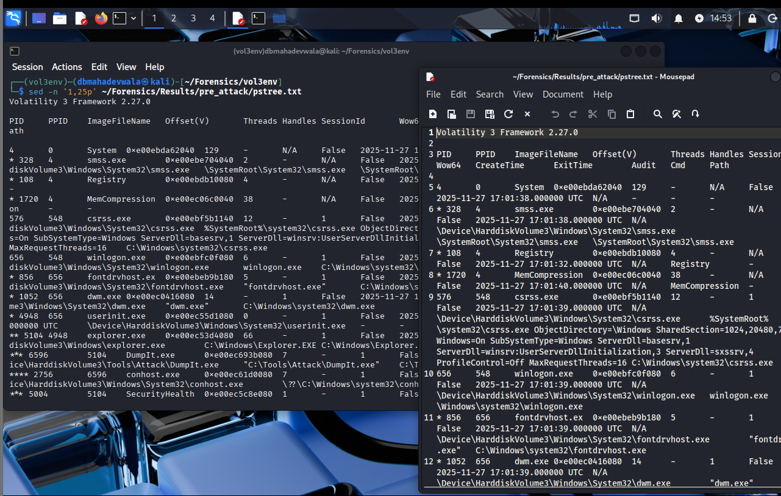

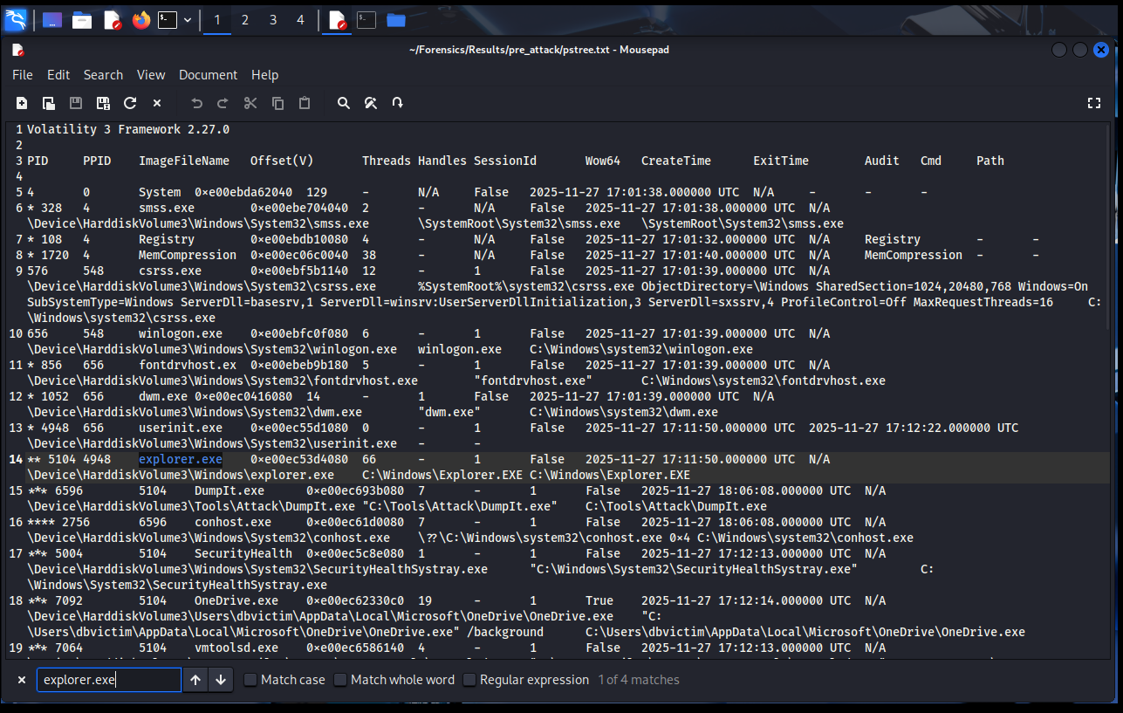

The windows.pstree.PsTree output visualises parent/child relations. In the baseline:

* explorer.exe is spawned by userinit.exe under winlogon.exe, reflecting a normal interactive logon.
* Downstream processes from explorer.exe are benign: standard shell components, OneDrive sync, Edge, etc.
* There is no abnormal command-line tool (e.g., cmd.exe, powershell.exe) chained from explorer.exe at this stage.

This hierarchical view will be essential later when we show cmd.exe → conhost.exe → DumpIt.exe / mimikatz.exe appearing only in the attack image.

### 3.2.3 Baseline network activity

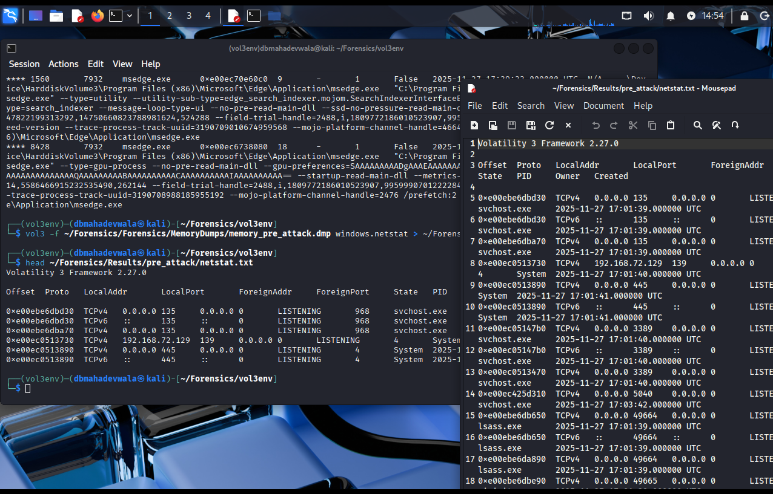

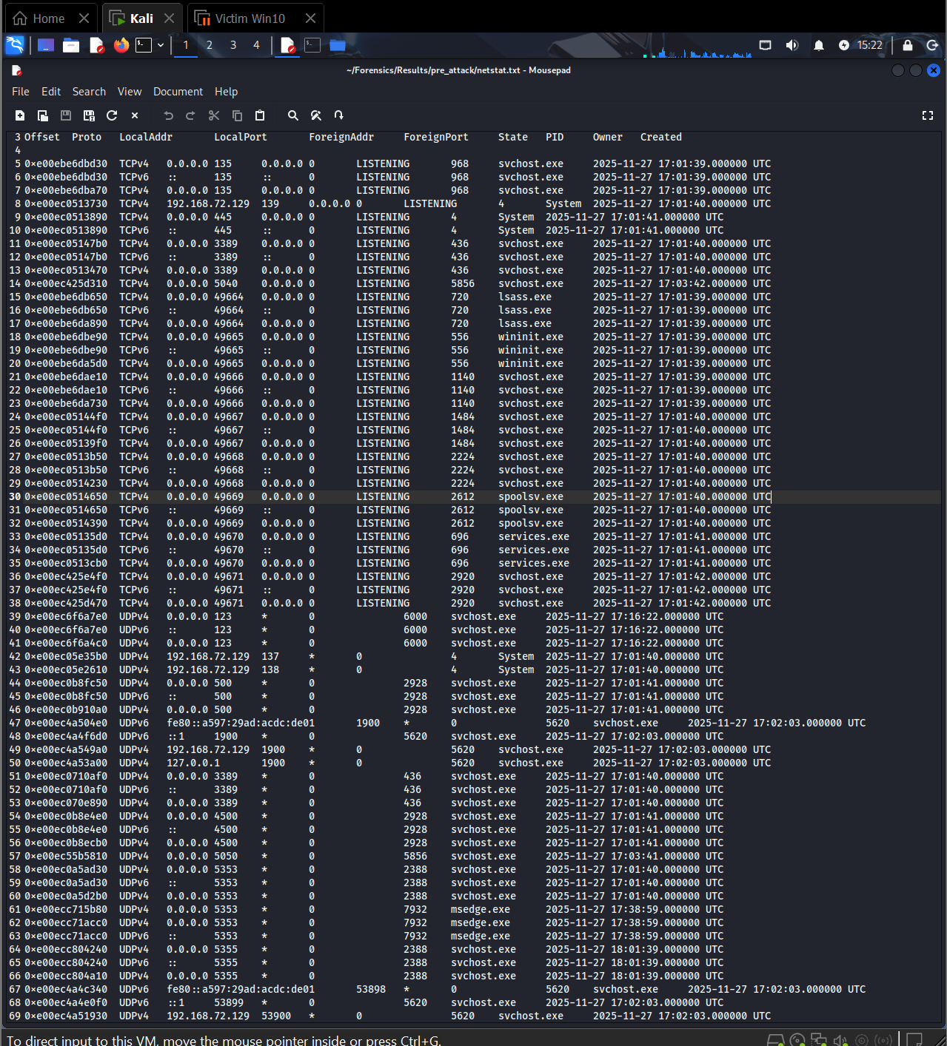

The windows.netstat.NetStat output lists TCP and UDP connections and listeners:

* Local ports primarily associated with svchost.exe (Windows services), lsass.exe, and system components.
* No outbound connections to suspicious external IPs; traffic is limited to the local network and routine Windows services.
* There is no established connection linked to attacker tools at this time.

Saving this output provides a reference for normal port usage. Later we will confirm that the attack phase does not introduce external C2 channels, supporting the conclusion that this was a local / hands-on intrusion scenario.

### 3.2.4 Baseline DLL inventory

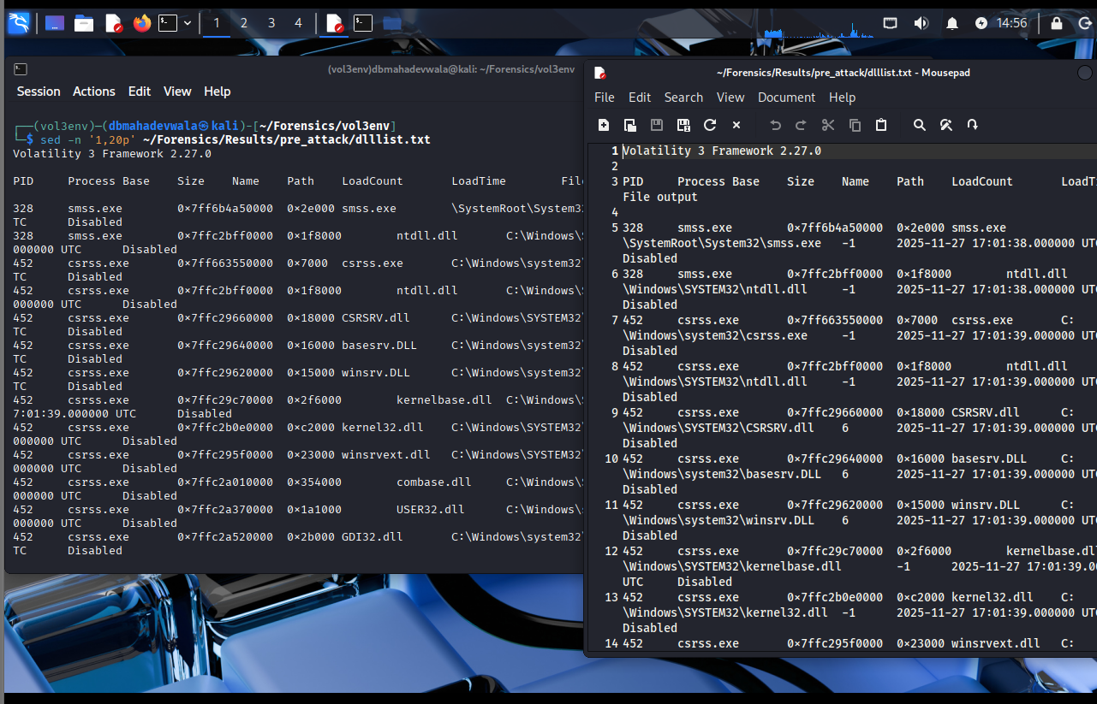

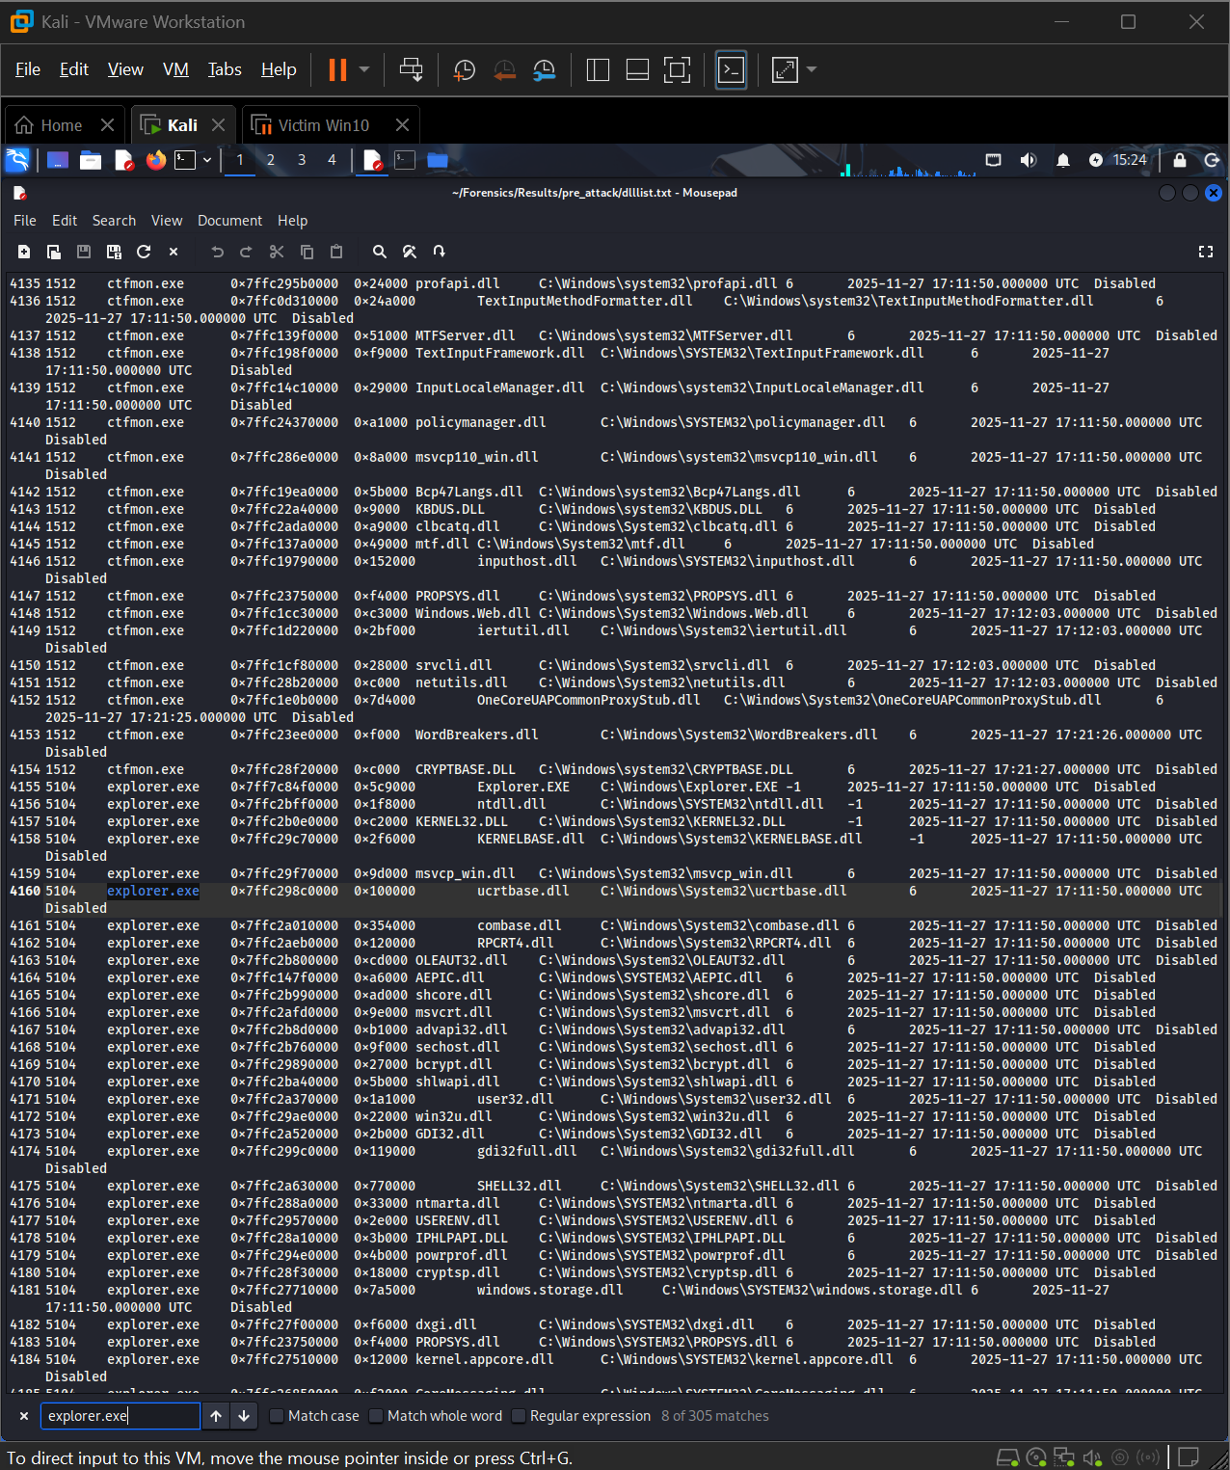

Using windows.dlllist.DllList, the DLLs loaded by explorer.exe are enumerated. The screenshot highlights:

* Only signed, Microsoft-supplied modules located under C:\Windows\System32 and related OS folders.
* No modules mapped from user-writable locations such as C:\Users\<user>\AppData\... or from the attack tools directory.
* Timestamps and load addresses consistent with a stable, long-running explorer session.

This provides strong evidence that prior to the attack, the shell process was not yet interacting with or loading any binaries from the planned attack directory (C:\Tools\Attack / Mimikatz).

### 3.2.5 Baseline handle usage

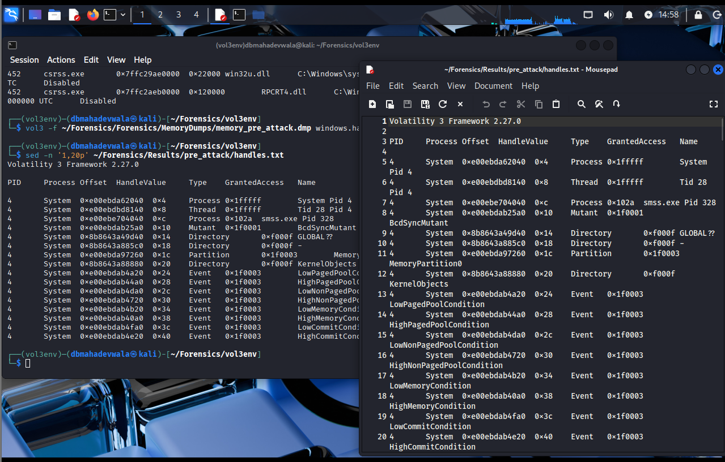

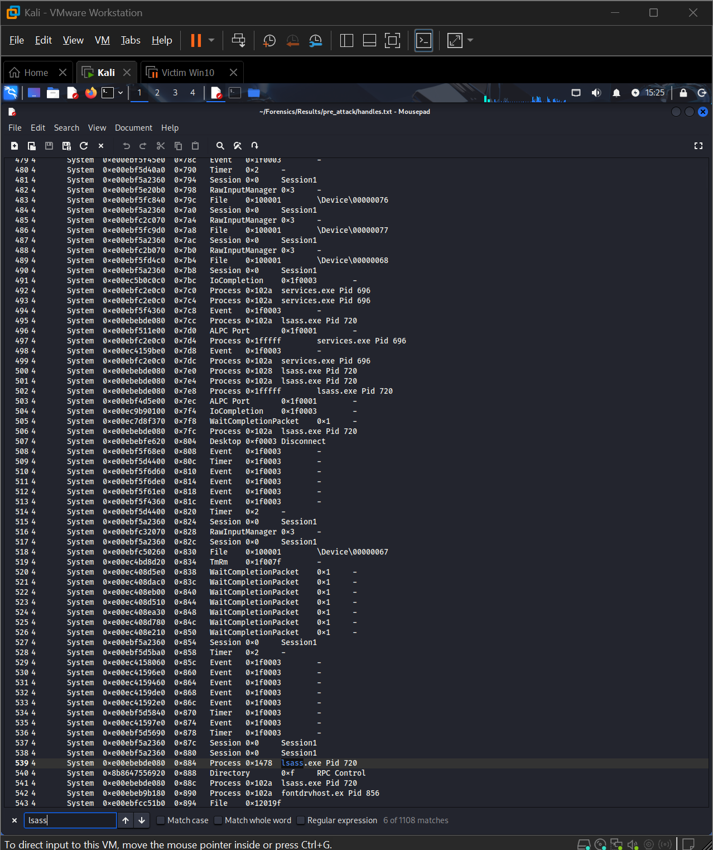

The windows.handles.Handles output in the baseline is used to understand “normal” object access:

* lsass.exe holds token, key, and named pipe handles related only to its core authentication duties.
* There are no handles from unusual processes into lsass.exe or sensitive security objects.
* File and device handles generally reference system paths, registry keys, and benign services.

This clean handle landscape will later be contrasted against the attack dump, where mimikatz.exe opens sensitive handles into lsass.exe and where DumpIt.exe interacts with low-level devices such as \Device\KsecDD.

## 3.3 During-attack analysis – live compromise image

The second memory image captures the system while the attack is in progress: DumpIt.exe is acquiring memory and mimikatz.exe is harvesting credentials. This is where the bulk of forensic evidence appears.

### 3.3.1 System profile during the attack

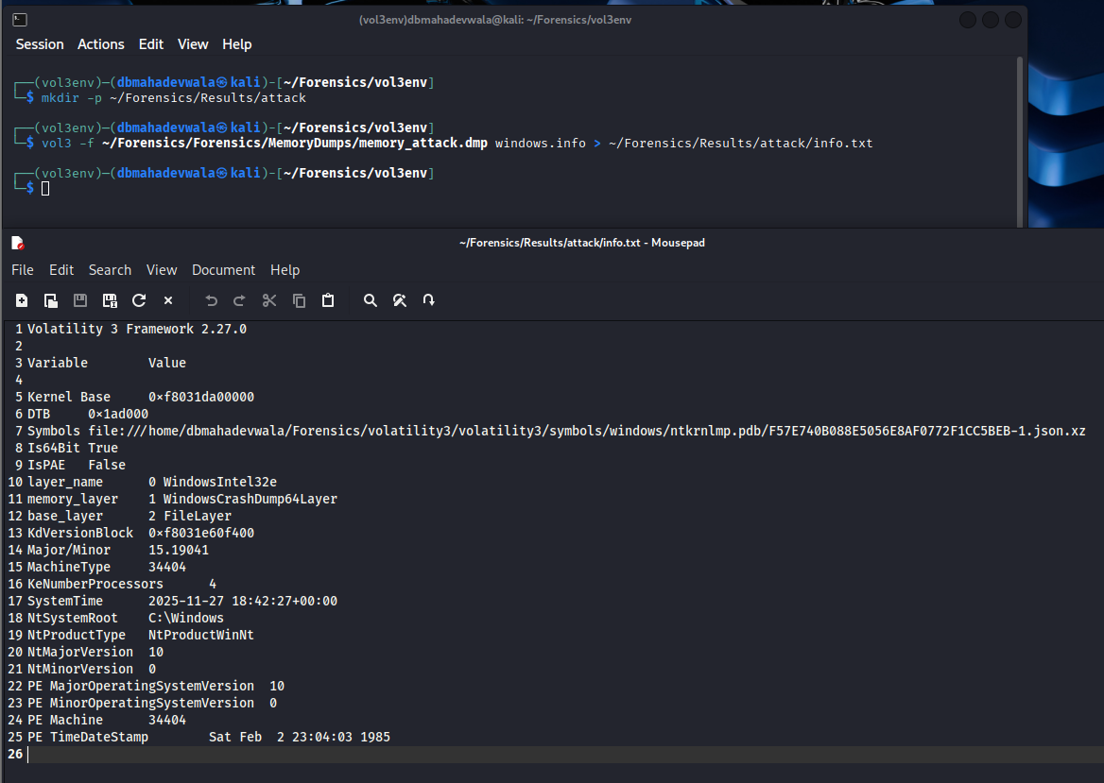

The windows.info output for memory_attack.dmp shows:

* Same OS version, kernel, and architecture as the baseline, confirming we are dealing with the same host and configuration.
* A later system time that aligns with the planned attack window.

This temporal anchor is important: it demonstrates that the malicious execution occurred after the baseline and before the post-attack snapshot.

### 3.3.2 Malicious processes identified

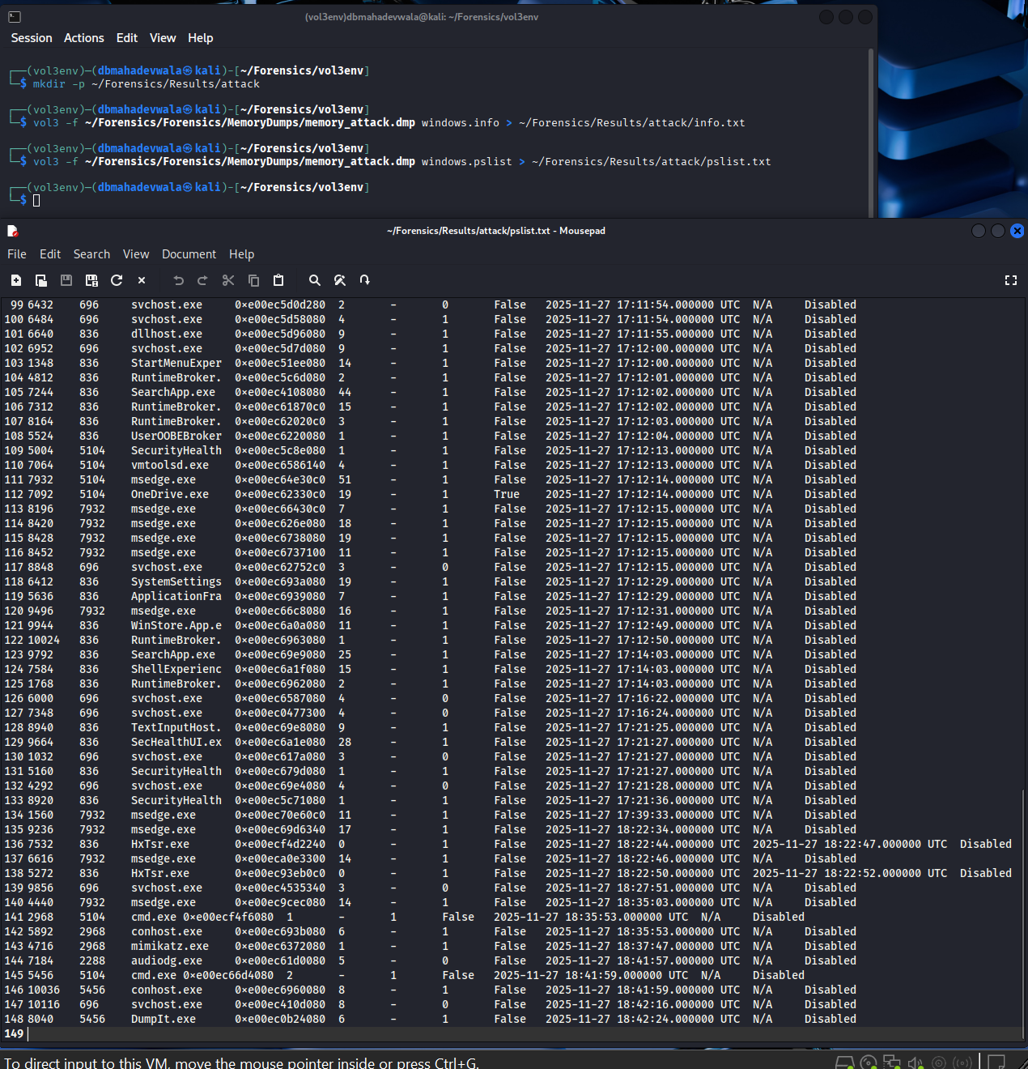The pslist output now includes new processes that were absent in the baseline:

* DumpIt.exe with a specific PID, typically a child of cmd.exe.
* An associated conhost.exe instance sharing the same console session.
* Depending on timing, mimikatz.exe may or may not still be running as a process at the moment of the dump; either way, subsequent artefacts confirm it executed.

Comparing this pslist to the pre-attack pslist immediately flags DumpIt.exe and the additional conhost.exe as suspicious. They do not belong to normal Windows operation and are directly linked to memory acquisition activity.

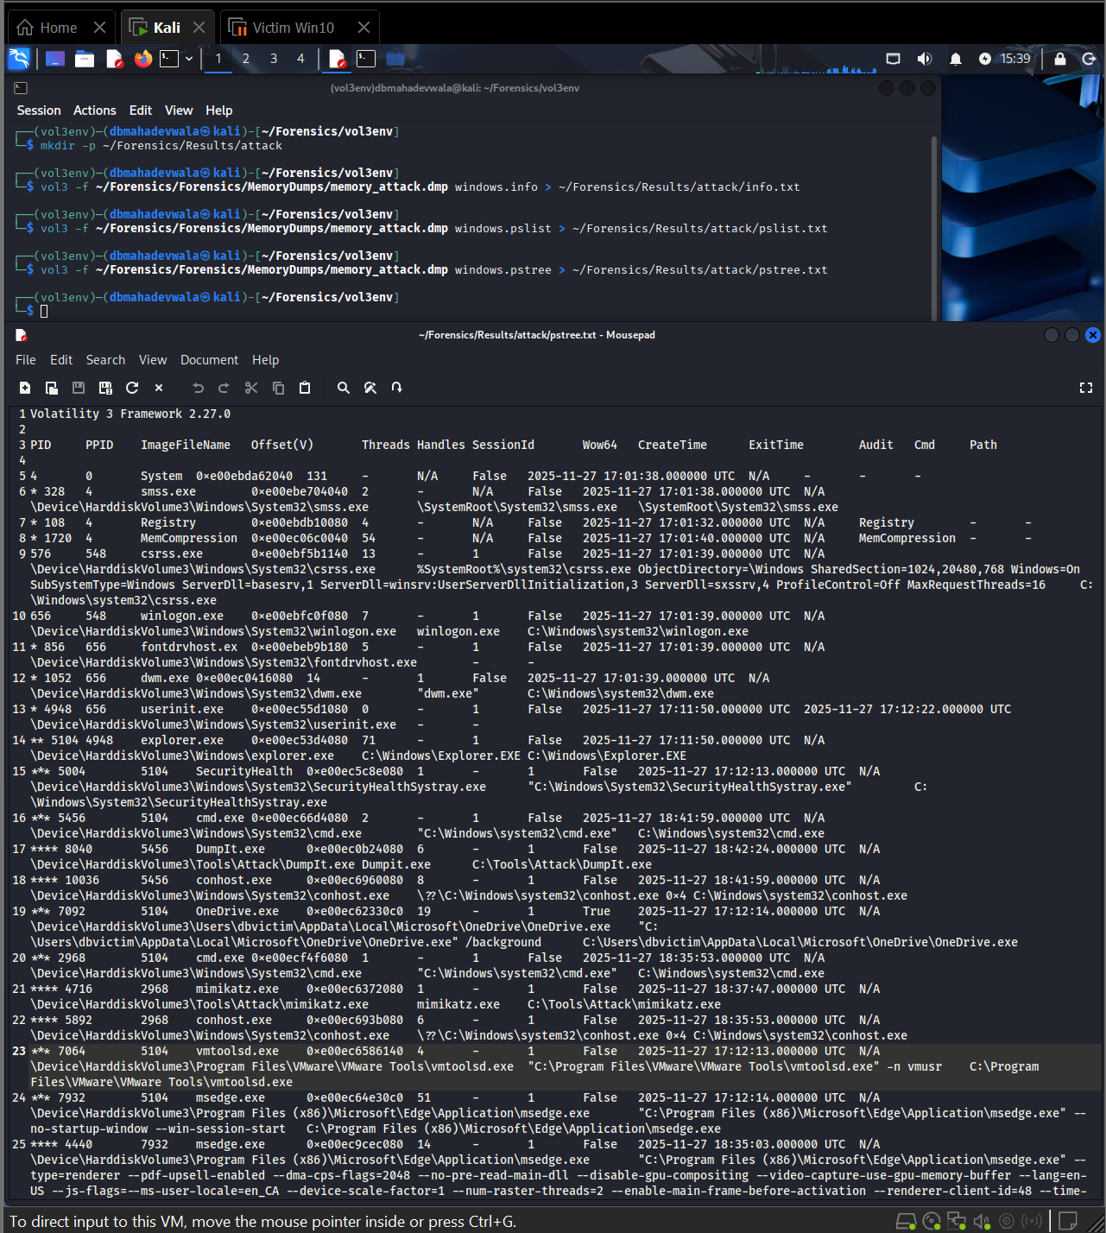

The pstree screenshot is one of the most important evidentiary artefacts:

* explorer.exe spawns cmd.exe, which is consistent with the attacker launching a command prompt from the GUI session.
* cmd.exe then spawns conhost.exe (console host).
* From this cmd.exe / conhost.exe chain, both DumpIt.exe and mimikatz.exe appear as child processes.

This tree reconstructs the attacker’s execution path:

User shell (explorer.exe) → command shell (cmd.exe) → console host (conhost.exe) → attacker tools (DumpIt.exe, mimikatz.exe)

From an IR perspective this proves that the malicious tooling was launched interactively under the logged-in user context, and not as a hidden service or scheduled task.

### 3.3.3 Network state during the attack

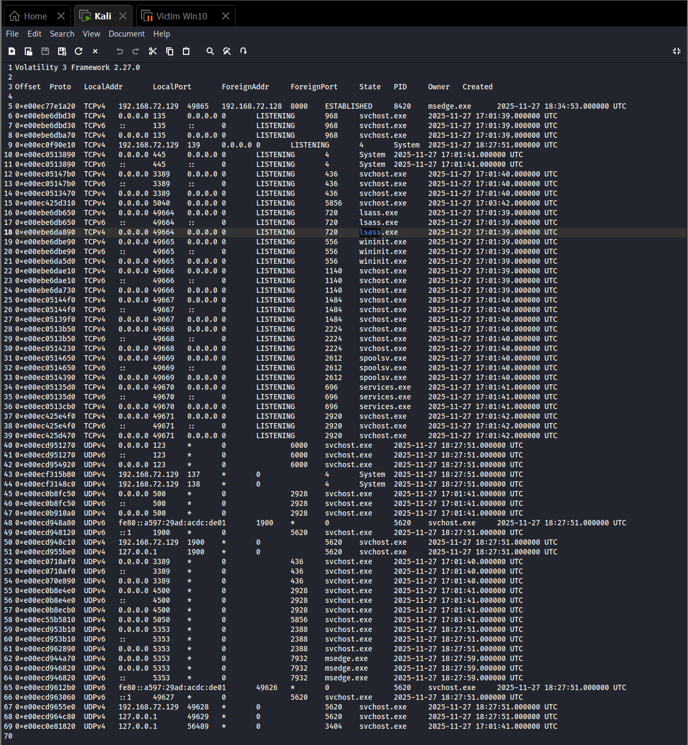

The netstat plugin output during the attack shows:

* Connections and listeners remain largely consistent with the baseline: service-bound ports on svchost.exe, system, and occasionally Edge.
* Crucially, there are no new outbound connections attributable to DumpIt.exe, mimikatz.exe, cmd.exe or conhost.exe.

This supports the conclusion that the attacker operated locally and exfiltration (if any) did not happen over a separate network channel from this host. The primary risk demonstrated here is credential theft and memory exposure, not remote C2.

### 3.3.4 DLLs loaded by attacker tools

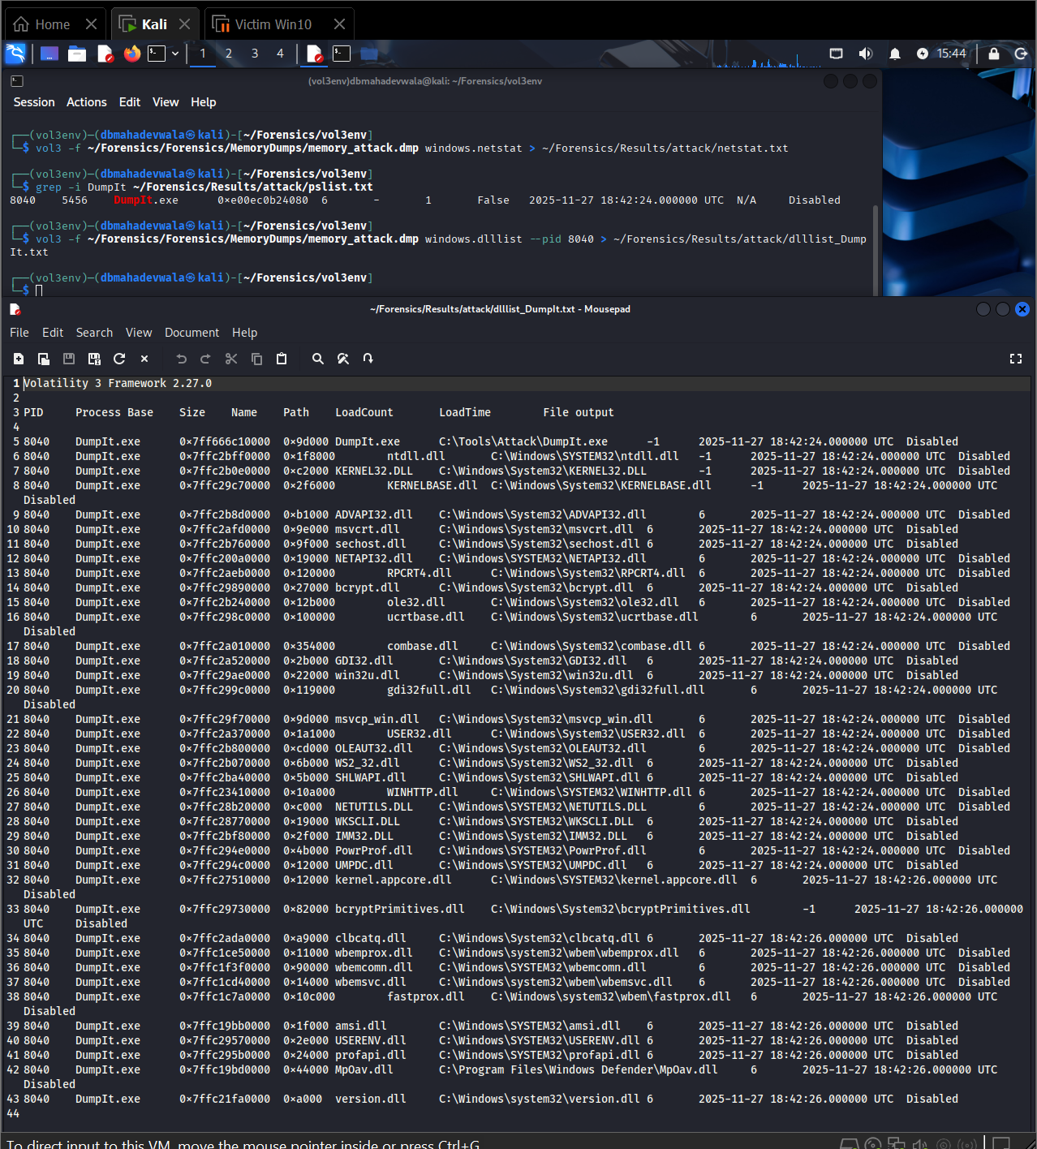

Using dlllist filtered for the PID of DumpIt.exe, the screenshot shows:

* A mixture of standard system DLLs (e.g., KERNEL32.DLL, ADVAPI32.DLL, ntdll.dll) and DumpIt-specific modules.
* Libraries providing low-level access to physical memory and OS internals.

This confirms DumpIt.exe is not just a renamed benign binary; it is a full memory acquisition tool leveraging system APIs and driver interfaces.

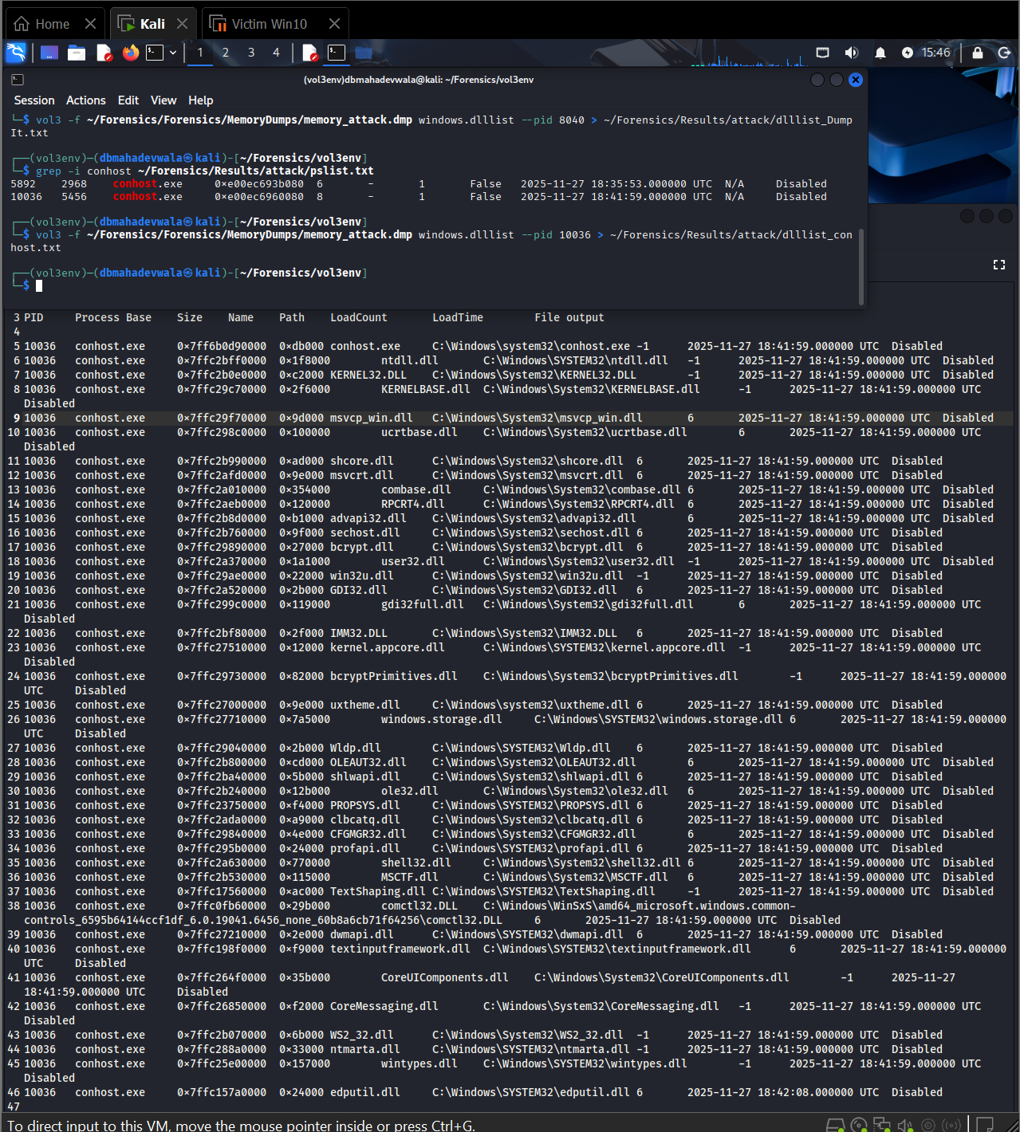

The DLL list for the conhost.exe instance associated with the attack shows:

* Usual console components plus additional libraries that match the time window of the attack.
* The key point is the tight coupling of this conhost.exe with DumpIt.exe and mimikatz.exe in pstree and pslist, showing that this console session is the attacker’s staging context.

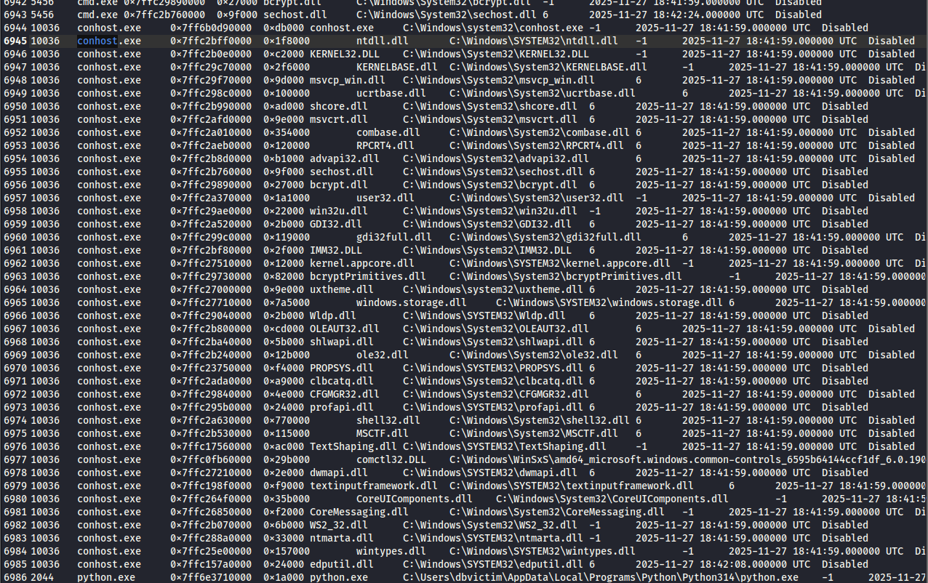

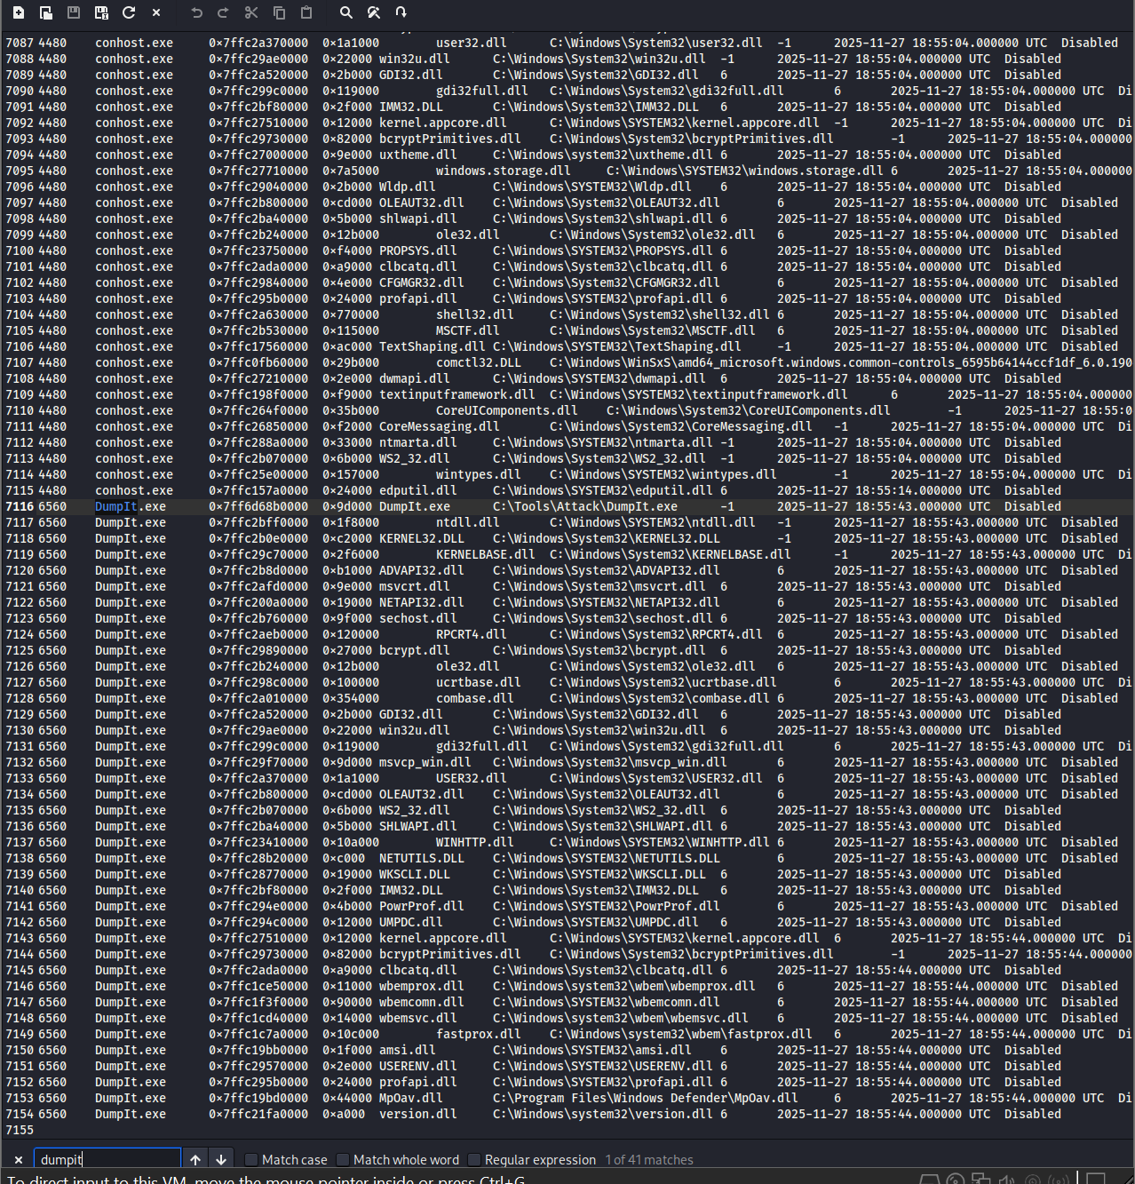

These additional dlllist screenshots reinforce the relationship between conhost.exe and DumpIt.exe:

* They show that conhost.exe and DumpIt.exe share a number of loaded modules (console input/output, window management).
* The temporal correlation of these loads with the attack window strengthens the argument that this specific conhost.exe instance is part of the malicious chain, not a random background console host.

### 3.3.5 Handles – evidence of credential access and memory dumping

Handles provide the strongest low-level evidence of what the attacker tools actually touched in memory.

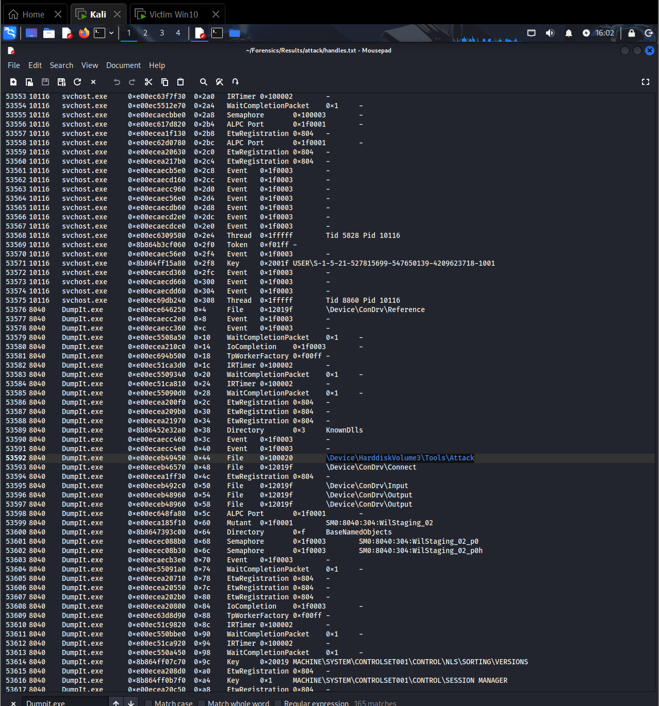

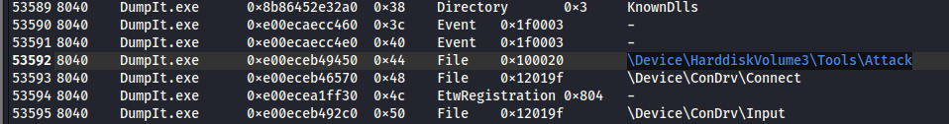

These screenshots show DumpIt.exe holding file handles to paths like \Device\HarddiskVolume3\Tools\Attack or similar. This demonstrates:

* The process is running from the expected attacker tools directory created in Phase 2.
* DumpIt is interacting with the underlying volume device and its own executable path, consistent with an acquisition tool reading physical memory and writing an output dump.

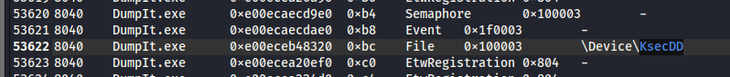

This is one of the most critical artefacts. It shows DumpIt.exe with a handle to \Device\KsecDD:

* \Device\KsecDD is a kernel-mode driver used by Windows for cryptographic operations and security. Tools that open handles to this device are typically performing privileged memory operations or cryptographic key extraction.
* Seeing DumpIt.exe interact with KsecDD confirms it is operating at kernel level, not just userland. From a DFIR perspective this is strong evidence that the tool had full access to system memory and sensitive key material.





These screenshots reveal mimikatz.exe holding process and thread handles targeting lsass.exe:

* The handle types and access masks (e.g., PROCESS_ALL_ACCESS) match the behaviour required for LSASS credential dumping.
* Multiple handle entries indicate that mimikatz opened and interacted with LSASS repeatedly, not just a single benign query.

In a real-world incident report, these handles constitute direct proof of credential theft: they show the attacker’s tool reading the memory of the Local Security Authority.



This screenshot shows explorer.exe holding file handles into the Mimikatz directory under C:\Tools (e.g., \Device\HarddiskVolume3\Tools\Mimikatz):

* It confirms that the logged-in user’s shell browsed or executed content from the Mimikatz folder.
* Combined with the pstree chain, this ties the malicious tool activity to the interactive desktop session rather than a background system account.

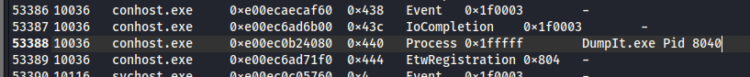

Here, conhost.exe has a process handle to DumpIt.exe (or shares console resources). This further cements:

* The relationship between the console host and DumpIt as part of a single malicious session.
* That the handles for conhost.exe are not generic; they specifically refer to the attack tooling.

Taken together, the handle evidence shows:

* DumpIt accessed kernel-level security devices (KsecDD) and the underlying disk.
* Mimikatz accessed LSASS process memory.
* Explorer and conhost were instrumental in launching and hosting these tools.

## 3.4 Post-attack analysis – cleanup and residual artefacts

The third memory image captures the system after the attack tools have been stopped but before the system was rebooted. This phase is useful to understand residues and what an attacker attempted to clean up.

### 3.4.1 Processes after the attack

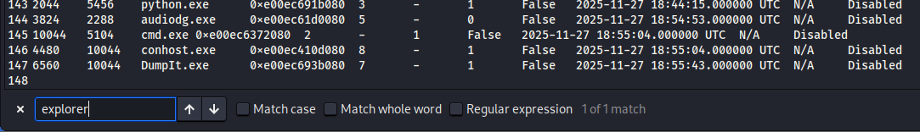

The pslist output reveals:

* DumpIt.exe and an associated conhost.exe may still be present (depending on where in the shutdown sequence the image was taken), or they might have exited but left artefacts.
* mimikatz.exe is no longer listed as a running process.

From an IR view this suggests the attacker terminated mimikatz first (perhaps after dumping credentials to disk or clipboard) and may have ended the console session, but traces of DumpIt or the acquisition environment can still persist.



The post-attack pstree shows:

* The same explorer.exe → cmd.exe → conhost.exe → DumpIt.exe lineage, but without an active mimikatz.exe child.
* This demonstrates that the command shell and DumpIt context still exist in memory, even though the credential dumping tool has been closed.

This snapshot is indicative of a typical attacker behaviour: use an interactive console session, run tools, then close only the most incriminating binary.

### 3.4.2 Residual file and handle associations

****Even though mimikatz.exe is no longer running, explorer.exe still holds handles pointing to the Mimikatz folder or files:

* This reveals that the GUI shell continues to reference the directory used earlier, e.g., through open Explorer windows or shell extension caches.
* It demonstrates that residual artefacts can expose prior tool usage even after processes exit.

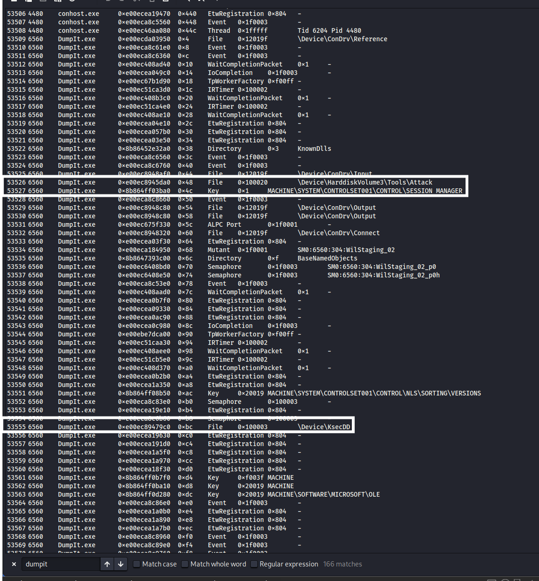

DumpIt in the post-attack dump still shows handles to KsecDD and the attack tools directory:

* This shows that DumpIt remained active at the time of the final snapshot, continuing to have kernel-level access.
* It also indicates that the attacker did not fully terminate or unload the acquisition tool.

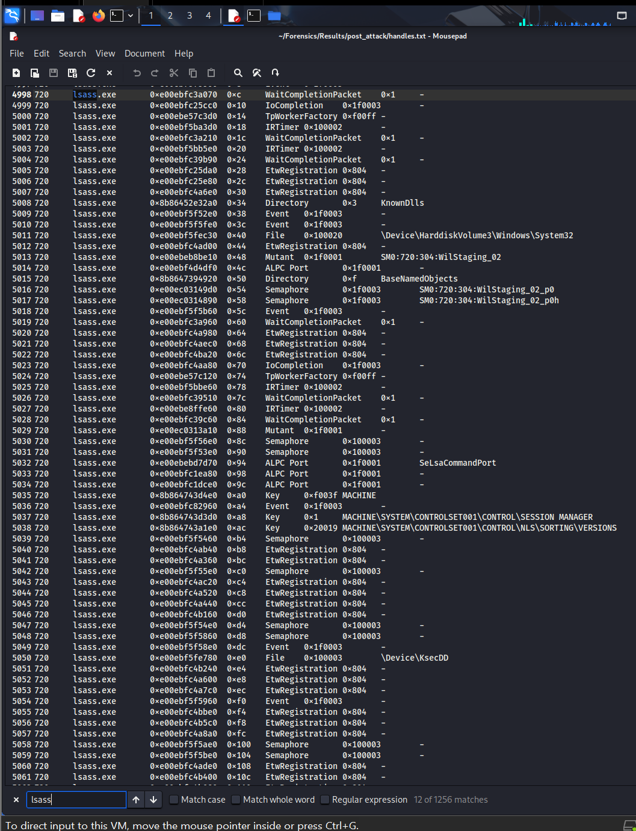

The handles for lsass.exe and related security components show:

* Normal LSASS activity plus associations with KsecDD and other security objects.
* In combination with the earlier mimikatz handles, this demonstrates a sequence where LSASS remained active after being read by mimikatz; there is no sign of LSASS having been crashed or disabled, which would have been more obvious for defenders.

### 3.4.3 Network after the attack

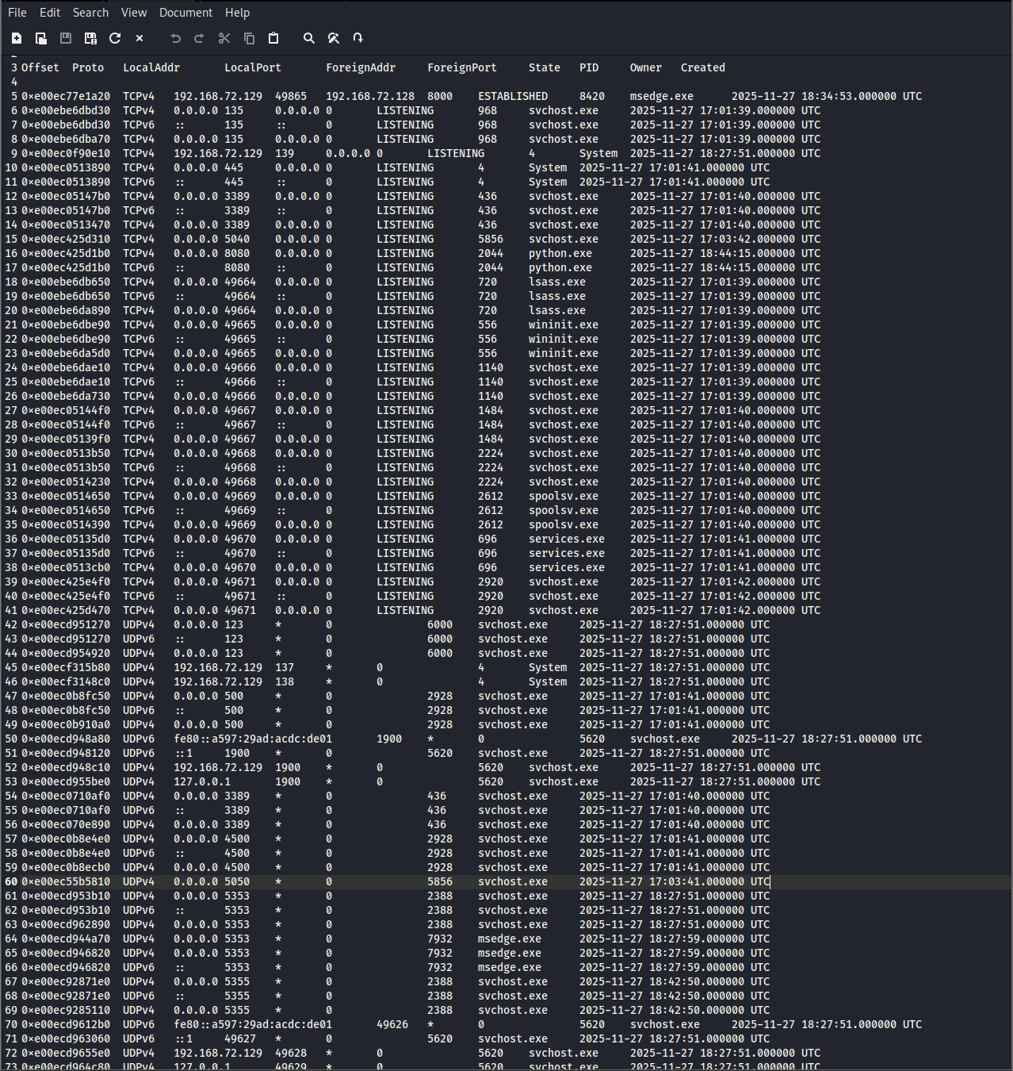

The netstat output for the post-attack dump remains similar:

* No additional suspicious outbound connections appear.
* Existing service ports are consistent with the baseline, reinforcing the assessment that the primary malicious activity was local credential access and memory dumping, not network-based exfiltration.

## 3.5 Cross-dump comparison of key processes

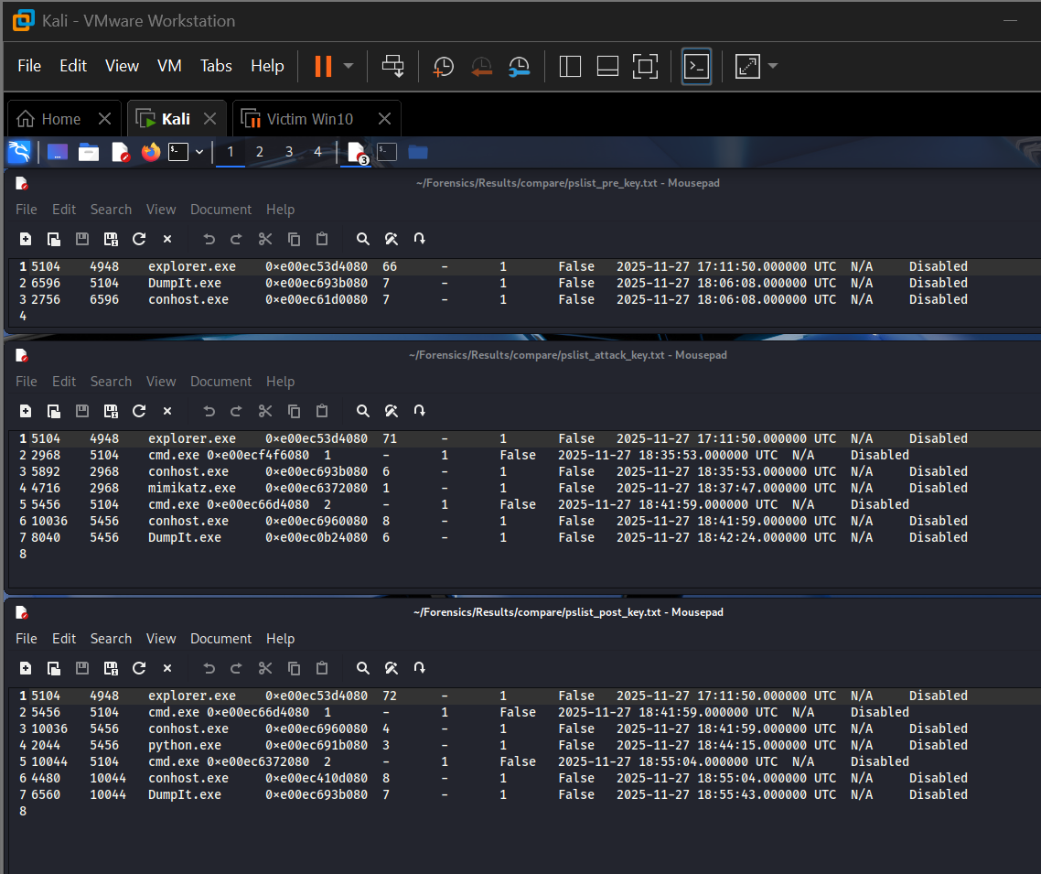

This screenshot contrasts selected high-value processes (explorer.exe, cmd.exe, conhost.exe, DumpIt.exe, mimikatz.exe, lsass.exe) across the three dumps. The following table summarises the comparison in report form (you can reconstruct it from pslist or the screenshot):

| **Process** | **Pre-attack dump** | **During-attack dump** | **Post-attack dump** |
| --- | --- | --- | --- |
| explorer.exe | Present, parent userinit, no link to attack tools | Present; parent of cmd.exe that launches tools | Present; still holds handles to Mimikatz directory |
| cmd.exe | Not present or only short-lived baseline activity | Present as child of explorer.exe; parent of conhost.exe and attacker tools | May still be present with conhost.exe and DumpIt chain |
| conhost.exe | Only generic console hosts (if any) | Specific instance associated with cmd.exe, child for DumpIt.exe / mimikatz.exe | Associated with cmd.exe / DumpIt.exe, but no active mimikatz.exe child |
| DumpIt.exe | Absent | Present; child of cmd.exe; holds KsecDD and disk handles | Present or recently exited; still has kernel-level and tool directory handles |
| mimikatz.exe | Absent | Present; child of cmd.exe / conhost.exe; opens LSASS handles | No longer listed as a running process, but handles and explorer references remain |
| lsass.exe | Present with normal handles and DLLs | Present; targeted by mimikatz.exe handles and possibly by DumpIt via full memory access | Present; shows no crash but continues normal activity after being accessed |

### 3.5.1 Pre- vs During-attack

Comparing the baseline and attack images shows a clear escalation:

* **New processes**: cmd.exe, a dedicated conhost.exe, DumpIt.exe and mimikatz.exe appear only in the attack dump.
* **Process hierarchy**: The pstree shifts from a pure user-interface tree to one that includes a command shell hosting offensive tooling.
* **Handles and DLLs**: Previously clean processes now load additional DLLs and hold sensitive handles:
  + DumpIt.exe opens \Device\KsecDD and volume devices, giving it full memory dumping capability.
  + mimikatz.exe acquires full-access handles to lsass.exe, enabling credential theft.
  + explorer.exe gains file handles into the attack tools directory, tying the GUI session to the malicious executables.

From a DFIR perspective, this delta is sufficient to attribute the attack to interactive activity by the logged-in user or an attacker using that session.

### 3.5.2 During- vs Post-attack

Comparing the attack and post-attack images reveals the attacker’s cleanup behaviour:

* **Process termination**: mimikatz.exe is no longer running in the post-attack snapshot, while DumpIt and the console chain may remain. This suggests the attacker deliberately closed the more obviously malicious binary first.
* **Residual artefacts**:
  + explorer.exe still references the Mimikatz directory.
  + Handles from DumpIt to KsecDD and attack paths persist.
* **No new network activity**: The netstat output remains broadly unchanged, indicating no further exfiltration or lateral movement after the primary credential theft.

This phase is typical of an attacker trying to reduce their footprint while leaving the system running.

### 3.5.3 Combined view – Pre vs During vs Post

Looking at all three images together:

1. **Baseline** – A clean user session with standard Windows processes, normal LSASS activity, no interaction with attack tools, and benign network connections.
2. **Attack phase** –
   * Introduction of offensive tooling (DumpIt.exe, mimikatz.exe) launched via a user interactive shell (explorer.exe → cmd.exe → conhost.exe).
   * Kernel-level interaction (DumpIt.exe → \Device\KsecDD) confirming full memory access.
   * Direct credential theft activity (mimikatz.exe handles into lsass.exe).
   * No evidence of remote C2, suggesting local or “hands-on-keyboard” compromise.
3. **Post-attack** –
   * Termination of mimikatz.exe, but ongoing presence of DumpIt and console context.
   * Residual file and handle references from explorer and security components, which provide forensic proof of prior malicious activity even after the tools are closed.
   * System remains otherwise stable, with LSASS and core services running normally.

From an incident-response standpoint, this three-stage memory analysis provides:

* **Attribution of actions** – which processes executed, in what order, and under which parent process.
* **Scope of impact** – LSASS was accessed; full memory was dumped; however, no evidence of sustained network-based exfiltration or persistence mechanisms appears in the analysed artefacts.
* **Residual evidence** – even after attempted cleanup, handles and file references persist that clearly demonstrate the presence and use of DumpIt and mimikatz.

This completes the Phase 3 memory-forensic narrative and sets up Phase 4, where these technical findings can be translated into higher-level conclusions, recommendations, and mitigations.

# Errors Faced During the Investigation

Throughout the project, several technical challenges were encountered. These issues mirror realistic obstacles that occur during actual incident-response operations.

**1. Volatility 2 Compatibility Issues**

One of the major challenges involved the incompatibility between the memory dump format generated by DumpIt (.dmp) and the Volatility 2 framework. Some memory captures lacked the required profile support, causing Volatility 2 to fail or produce partial results. This is a common issue when working with modern Windows OS versions that rely on newer kernel structures not fully supported in Volatility 2.

**2. Insufficient Disk Space in the Kali VM**

The memory dumps were large (multiple gigabytes), and downloading them from the Windows VM to Kali often failed due to insufficient allocated virtual disk space. This required resizing the virtual disk, removing snapshots, and reconfiguring storage—an effort that consumed time and required careful handling to avoid corruption of the forensic workstation.

**3. Download Failures and Incomplete Transfers**

While attempting to transfer memory images via the Kali-hosted HTTP server, several attempts failed due to storage limitations and temporary network misconfigurations. This resulted in corrupted or incomplete downloads, requiring validation of hashes and re-transfer to ensure forensic integrity.

**4. Mimikatz Output Inconsistencies**

Mimikatz execution did not always yield plaintext credentials, which can happen when certain Windows security components block credential caching or when LSASS protection is partially enabled. This required validation of whether credential theft actually occurred and whether memory artifacts still substantiated the attack.

**5. Environment Isolation Conflicts**

Switching between NAT and Host-Only networking modes occasionally caused connectivity loss between attacker and victim VMs. Isolated forensic environments often require careful network reconfiguration to maintain reachability without exposing attack tools to the external network.

# Mitigation Steps and How Each Issue Was Resolved

**1. Volatility 2 Compatibility**

To overcome Volatility 2’s limitations, Volatility 3 was installed and used as the primary analysis engine because of its superior plugin coverage, modern Windows compatibility, and reduced dependency on OS profiles. This ensured full extraction of processes, handles, DLLs, and LSASS-related artifacts.

**2. Expanding Disk Space on Kali**

VM snapshots were removed to unlock disk-extension features. The Kali VM’s storage was expanded using VMware’s disk management interface, followed by filesystem resizing from within the VM. This allowed proper storage of large memory dumps and ensured uninterrupted forensic analysis.

**3. Ensuring Reliable Memory Transfers**

After disk expansion, memory dumps were transferred again using the embedded Python HTTP server method. The integrity of each file was then validated using sha256sum to confirm that no corruption occurred during transfer.

**4. Addressing Mimikatz Output Variability**

Even though plaintext passwords were not retrieved, memory dumps still showed LSASS access attempts, Mimikatz process handles, relevant DLLs, and unlocked security tokens. These forensic traces were sufficient to prove credential dumping activity and reconstruct the attack workflow.

**5. Stabilizing the Network Environment**

Host-Only networking was reinstated for attack execution to ensure the victim could not reach the external internet. Connectivity was tested via reciprocal ICMP checks before proceeding with the attack. This preserved the isolation necessary for a legitimate forensic laboratory environment.

# Recommendations

**1. Always Acquire Multiple Memory Captures**

Capturing *pre-attack*, *during attack*, and *post-attack* memory states dramatically enhances the accuracy of forensic timelines. This methodology should be adopted in real-world investigations wherever feasible.

**2. Validate Memory Image Integrity**

Memory dumps should always be hash-verified (MD5/SHA-256) before analysis to ensure forensic soundness. Integrity validation is critical in legal or enterprise breach-response contexts.

**3. Prefer Volatility 3 for Modern Windows Systems**

Volatility 3’s plugin architecture, OS-agnostic approach, and improved support for modern Windows versions make it the recommended tool for contemporary incident response work.

**4. Enable Secure Logging During Investigations**

Maintaining logs of all commands executed, file transfer methods used, and intermediate results is essential for reproducibility. This practice is a standard requirement for forensic chain-of-custody.

**5. Maintain Strict Environment Isolation**

All malware testing and exploitation activity must occur in an isolated network (Host-Only). This limits the risk of accidental propagation and ensures forensic containment.

**6. Use Automated Forensic Pipelines**

In enterprise environments, memory acquisition and triage tools such as Velociraptor, KAPE, and GRR Rapid Response can significantly accelerate analysis, especially when dealing with larger incident scopes.

**7. Perform Differential Analysis Across Dumps**

Cross-dump comparison is one of the most powerful techniques in memory forensics. It exposes privilege escalation, process injection, unauthorized credential access, and persistence artifacts that may not be visible in a single snapshot.

**8. Document Findings in a Structured IR Format**

Reports should always include:

* Executive summary
* Scope and objectives
* Methodology
* Evidence collected
* Analysis
* Comparisons
* Conclusion
* Recommendations

This ensures the document aligns with industry reporting standards used by IR teams such as Mandiant, CrowdStrike, and Deloitte Cyber.

# Conclusion

This investigation successfully replicated a full credential-theft attack chain and demonstrated how memory forensics can be used to reconstruct adversary behavior with high precision. Through three strategically timed memory captures, it was possible to map the evolution of system state from normal operation to active compromise and finally to the aftermath of the attack.

Volatility 3 provided extensive visibility into process execution, child–parent process relationships, LSASS interaction, loaded modules, handle objects, and other volatile artifacts that exposed the actions of Mimikatz even when the executable itself was no longer running. Differential analysis revealed critical behavioral shifts between baseline, active compromise, and post-attack states, thus providing a comprehensive timeline of malicious activity.

The methodologies, tools, and findings in this report reflect real-world digital forensics and incident-response workflows. The evidence collected and analyzed not only fulfills academic requirements but also demonstrates practical, industry-relevant forensic skills. This project is suitable for inclusion in a technical portfolio, GitHub repository, or professional resume.

# References

CrowdStrike. *What Is Mimikatz?*. CrowdStrike, <https://www.crowdstrike.com/en-us/blog/credential-theft-mimikatz-techniques/>

Gentilkiwi, Benjamin Delpy. *Mimikatz Project*. GitHub, [github.com/gentilkiwi/mimikatz](https://github.com/gentilkiwi/mimikatz).

Magnet Forensics. *DumpIt for Windows: Memory Acquisition Tool*. Magnet Forensics, <http://www.magnetforensics.com>.

Volatility Foundation. *Volatility 3 Framework Documentation*. Volatility Foundation, <volatilityfoundation.org>.

Moore, Harlan Carvey. *Windows Forensic Analysis Toolkit*. Syngress, 2018.

Ligh, Michael Hale, et al. *The Art of Memory Forensics: Detecting Malware and Threats in Windows, Linux, and Mac Memory*. Wiley, 2014.

Microsoft. *Credential Theft Mitigation Strategies*. Microsoft Docs, learn.microsoft.com.